S.B.I.O.A. MODEL Matric. & Hr. Sec. School

Chennai 600037

JANUARY 2024



MONTHLY REPORT –JANUARY 2024
ACADEMICS
Revision Examination I & II were held for Std X to XII from 03.01.2024.
ACHIEVEMENTS
02.12.2023
S Gayathri of Std XI B participated in SGFI for athletics. She had been selected to represent Tamil Nadu for School National Games.
Harish Raghav of Std XII A participated in SGFI for shooting. He had been selected to represent Tamil Nadu for School National Games.
02.01.2024
Tananya K.A. participated in the Inter Dojo Championship held at Decathlon, Mogappair and was placed Second in Individual Kumite, below 12 years category and Third in Individual category in Karate.
21.01.2024
State Level Silambam Artistic Championship was organized by OMS School of Silambam at Vellore on 21.01.2024. Sujay Sarvesh D. of Std VIII took part in it and won a Silver medal in Vel Kambu Veechu & a bronze medal in Vaal Veechu.
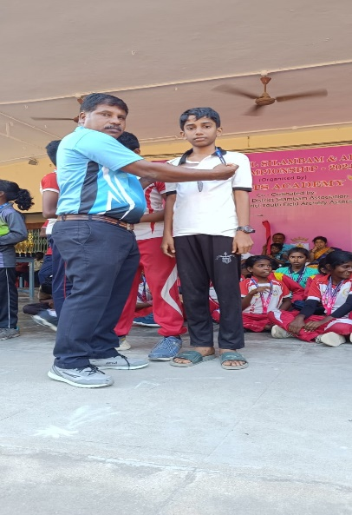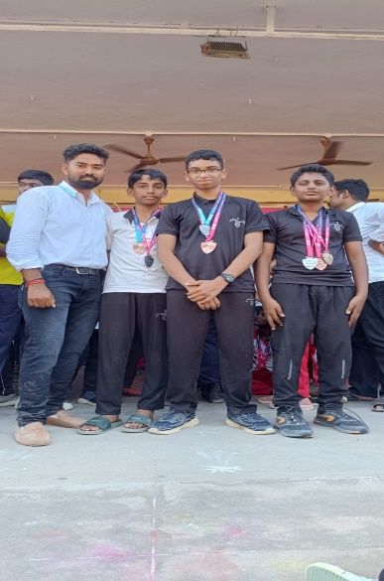
27.01.2024
Darshan of Std VI B has created the World Record in Abacus conducted by Elite World Records.
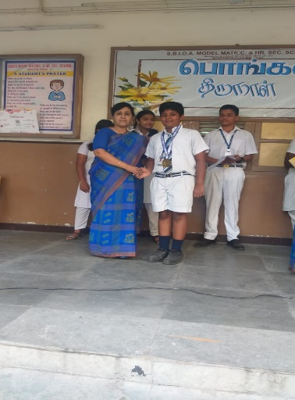
EVENTS & EXTRA CURRICULAR ACTIVITIES
05.01.2024
We celebrated Bharathiyar day with LKG and UKG children. Our children dressed up like Bharathiyar and a few children sang his song, dancing for his song. Mr. Salaikumarasamy, Dept of Tamil recited a kavithai and spoke about Bharathiyar. Then Bharathiyar songs and kavithaigal competitions were conducted for children.
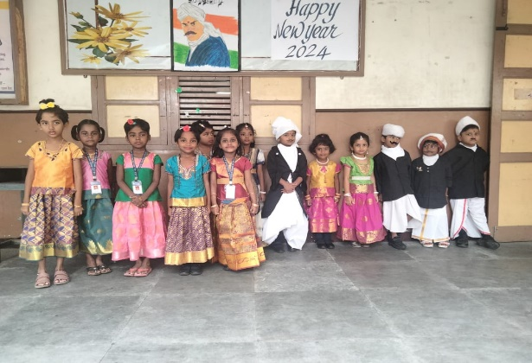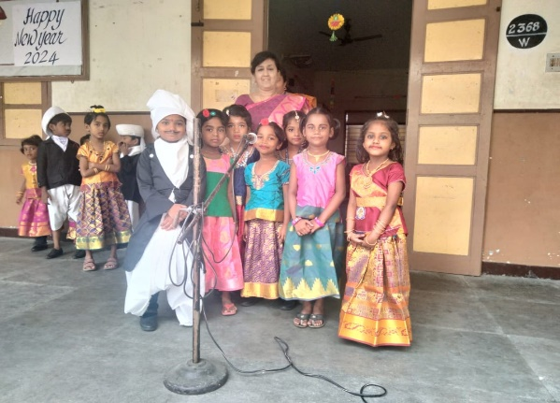
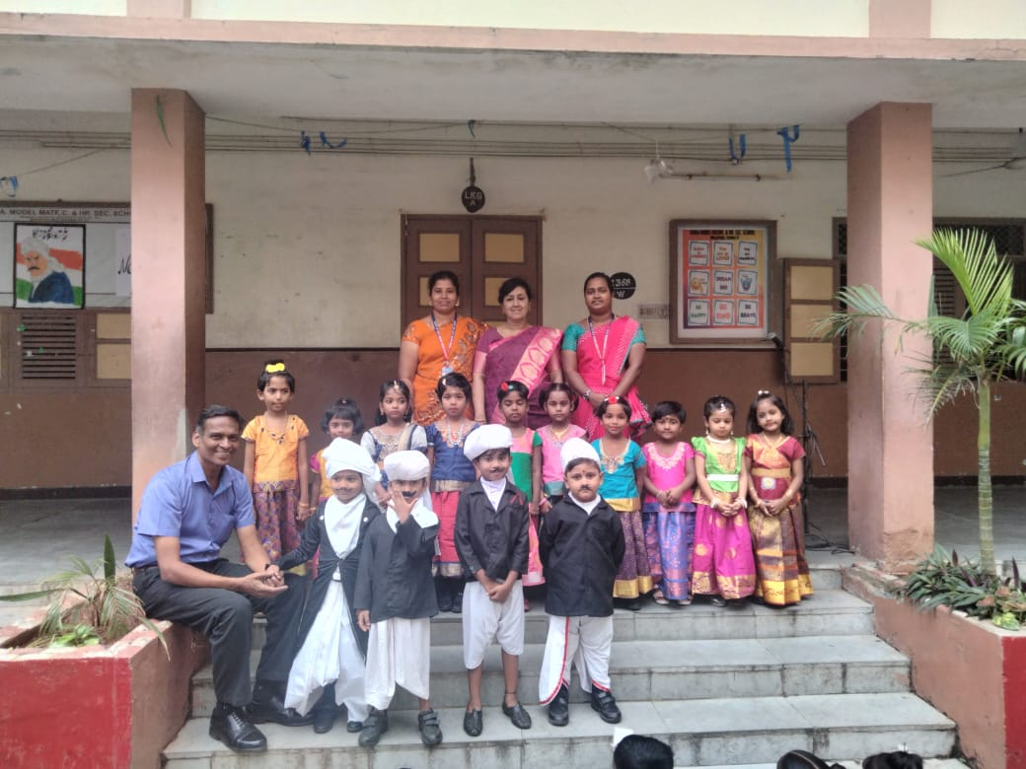
06.01.2024
Mrs. Hemlata Venkatesan, Mrs. K. Kugapriya, Mr. R. Harihara Subramanian, Mrs. S. Manvizhi, Mrs. Bindhuja, Mrs. S. Anuradha, Mr. A. Paary, Mrs. R. Anitha & Mrs. R. Dhivya took the students of Std IX- XII on a field trip to Dakshinachitra Museum on 06.01.2024. 125 students were present. The trip was started around 9.30am. The museum has the portrayal of South Indian architecture and culture such as Tamil Nadu, Kerala, Karnataka and Andhra Pradesh. The students had experienced the architecture, lifestyle, music, arts & crafts of South India. They gained knowledge about 18 authentic historical houses with contextual exhibition. They even purchased so many articles. Around 3pm they got into the bus and reached school around 5pm. They enjoyed the trip thoroughly.

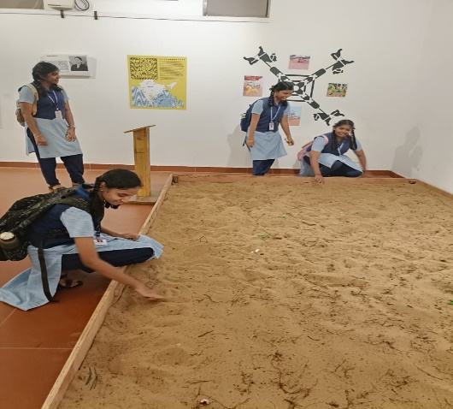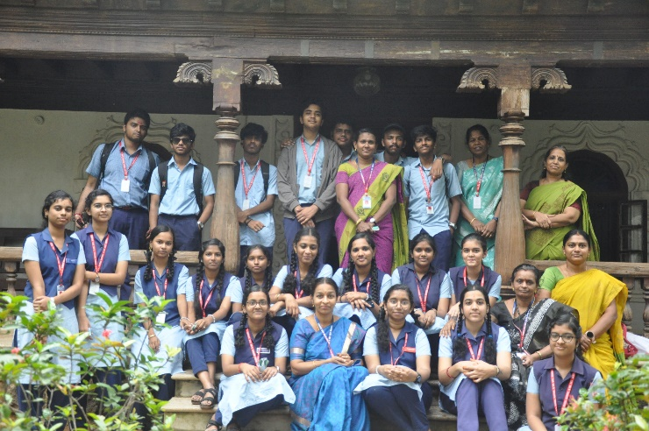

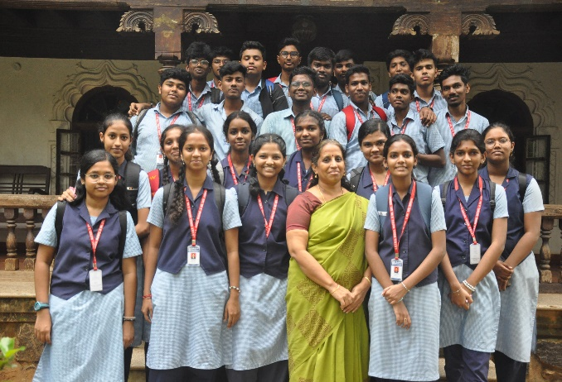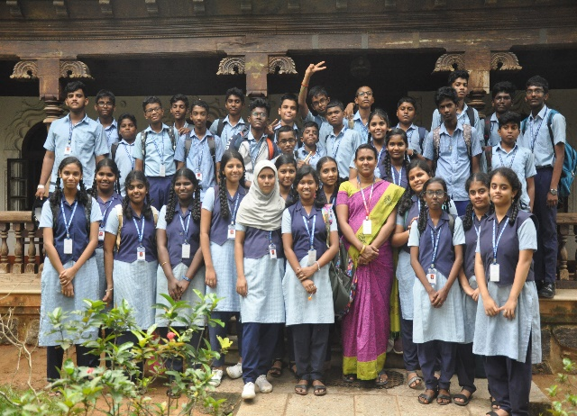

10.01.2024
Students of Std 5 were taken on a field trip to Rail Museum on (10/01/24). Number of 46 students were present. The children began the trip around 10:30 am in a school bus to the place. Students had a visual and practical experience of learning about the railways. Many different models of coaches and engines were exhibited at the museum which enlightened the learners. Students enjoyed the train ride which gave them a view of the landscape, around the museum. Many beautiful designs were made out of waste metals which gave treat to their eyes and to develop their imagination. The show was informative as it gave more information about factual knowledge of railways. On the whole it was a fun and safe trip for the students.
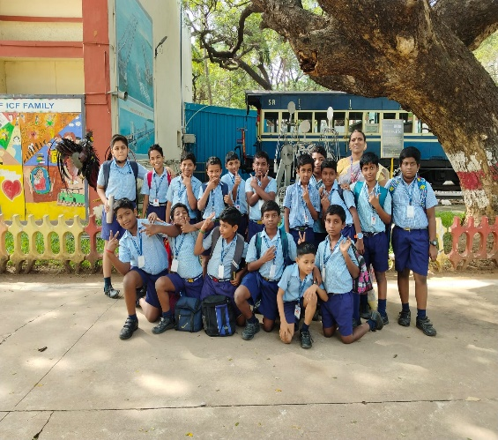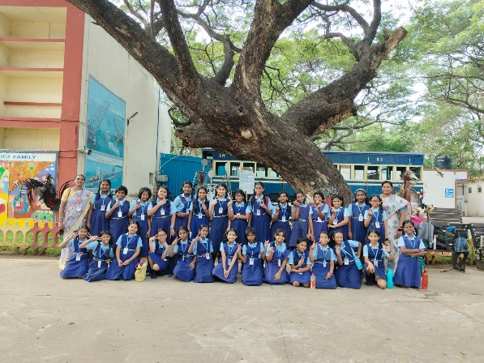
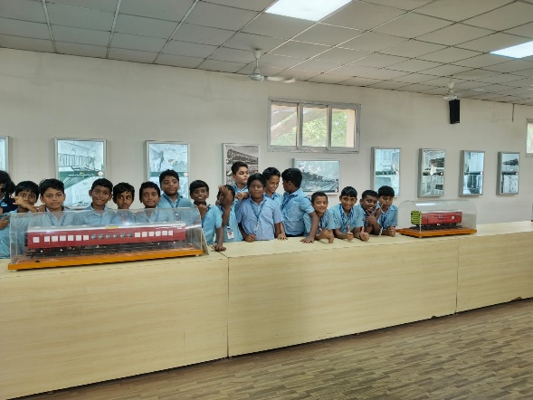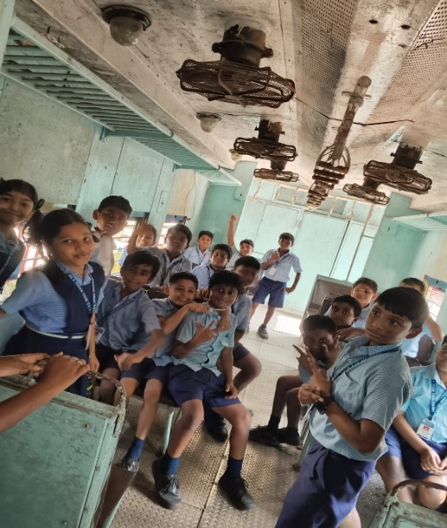

11.01.2024
The students of Std VIII were taken on a field trip to Egmore Museum. There were 32 students visited the place. We started the trip around 9. 30 a. m. and we reached the museum around 10.40 a. m. The students were much excited to visit the place. They watched the objects that cover a variety of artifacts and objects covering diverse fields including archeology, numismatics, zoology, natural history, sculptures, palm-leaf manuscripts, and Amravati paintings. The students enjoyed the trip and they were delighted to watch each and every object displayed in the museum. The students reached the school safely at 3.00 p. m.
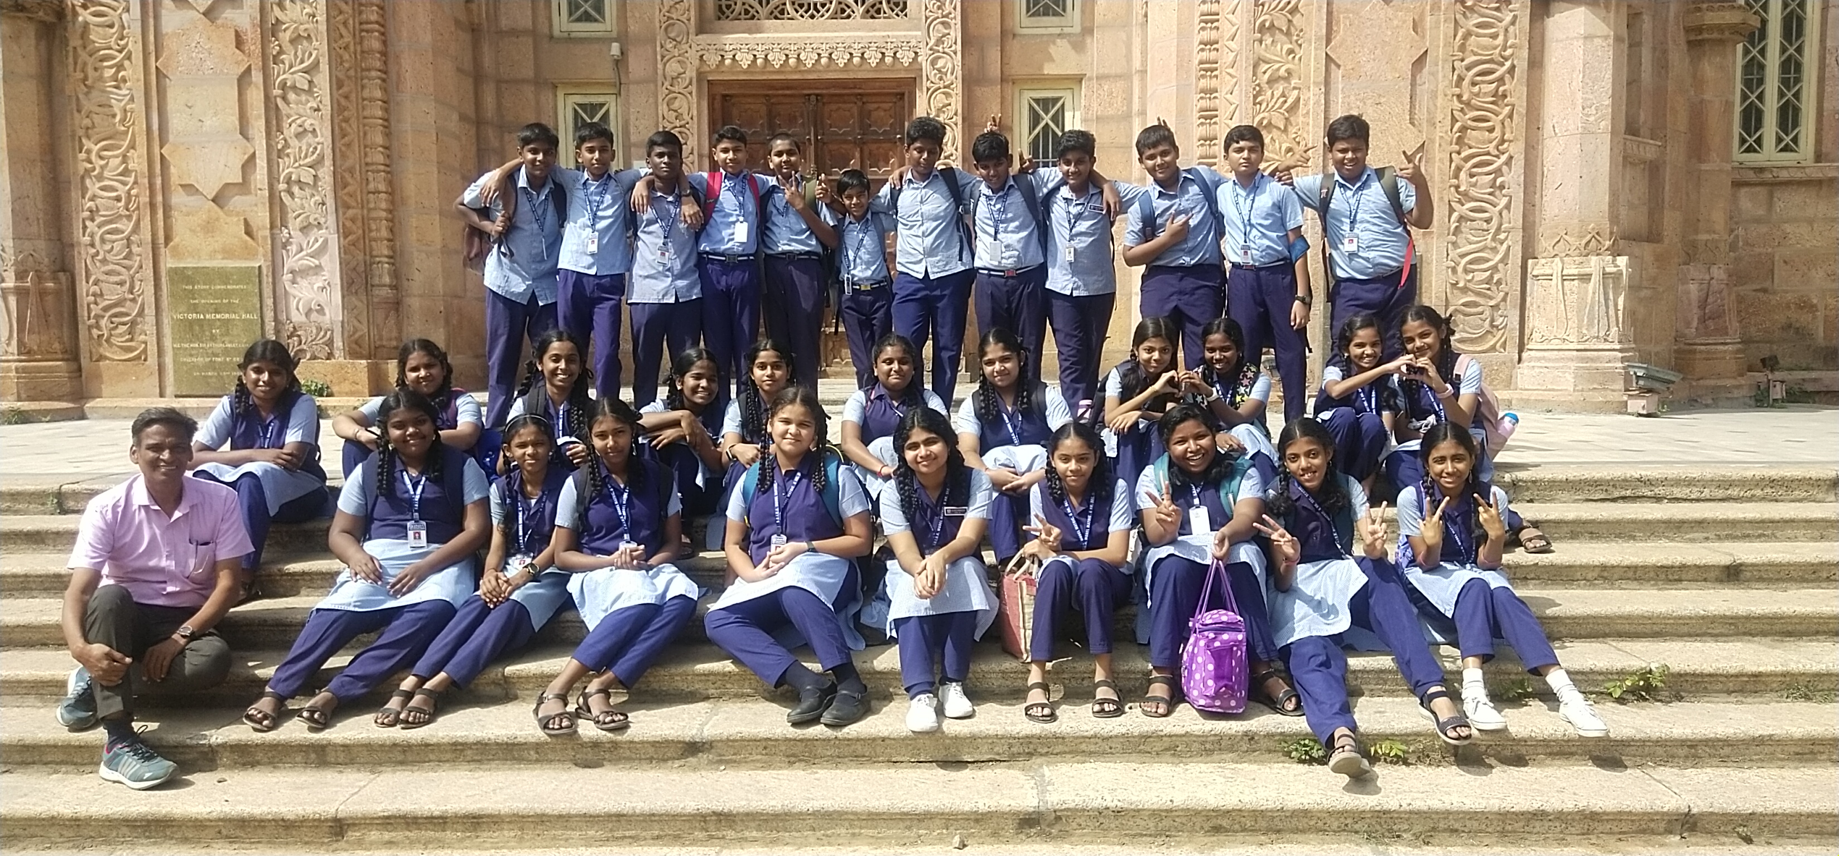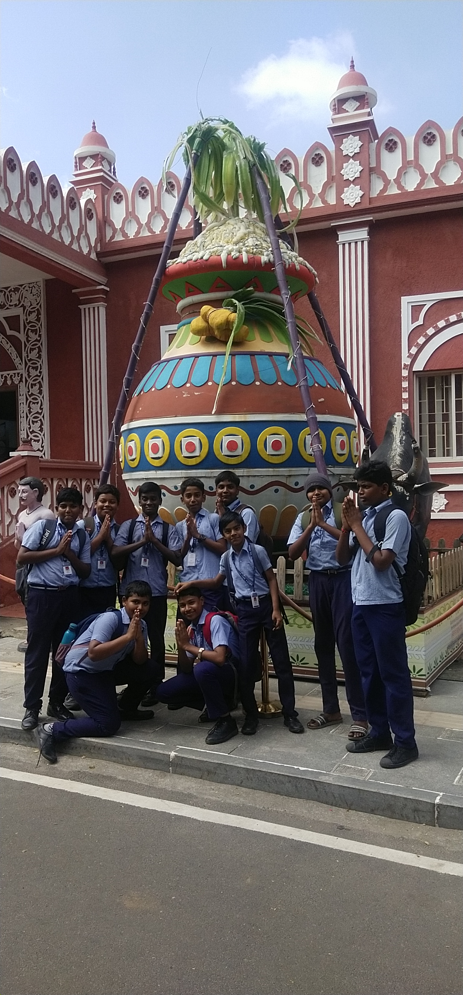
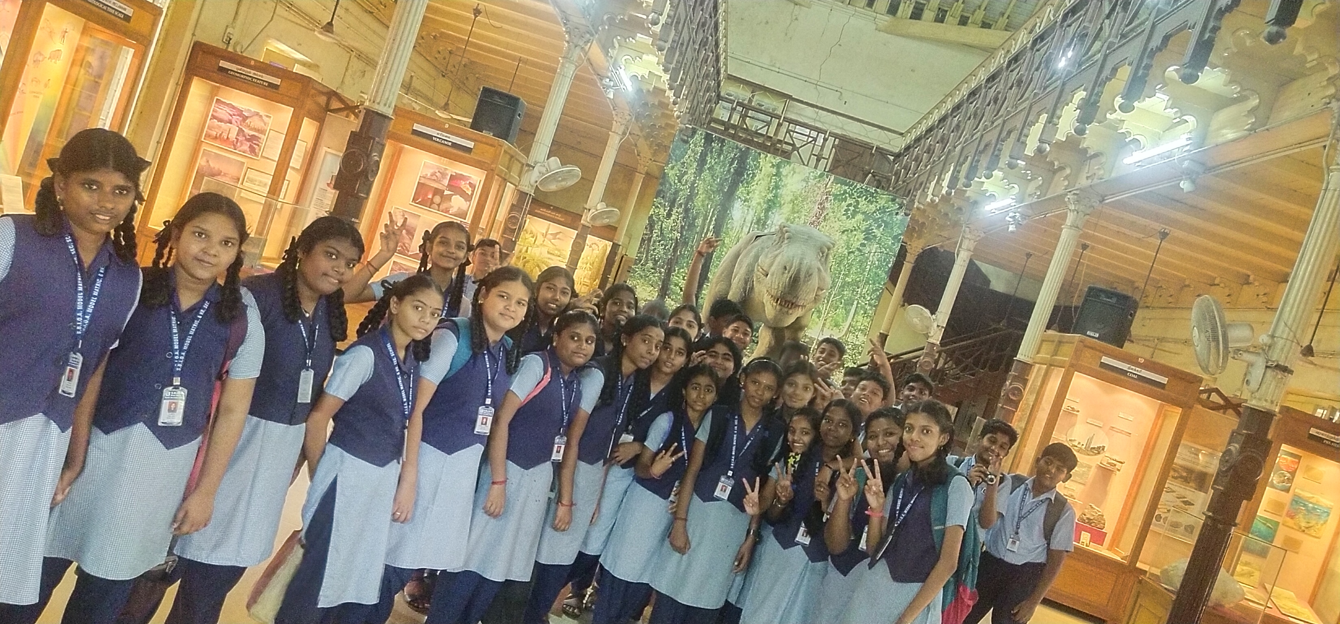
12.01.2024
Pongal was celebrated in a colourful way. It was celebrated to pay tribute to the farmers who toil the whole year for a good harvest. The students of LKG – Std IX came in traditional attire .
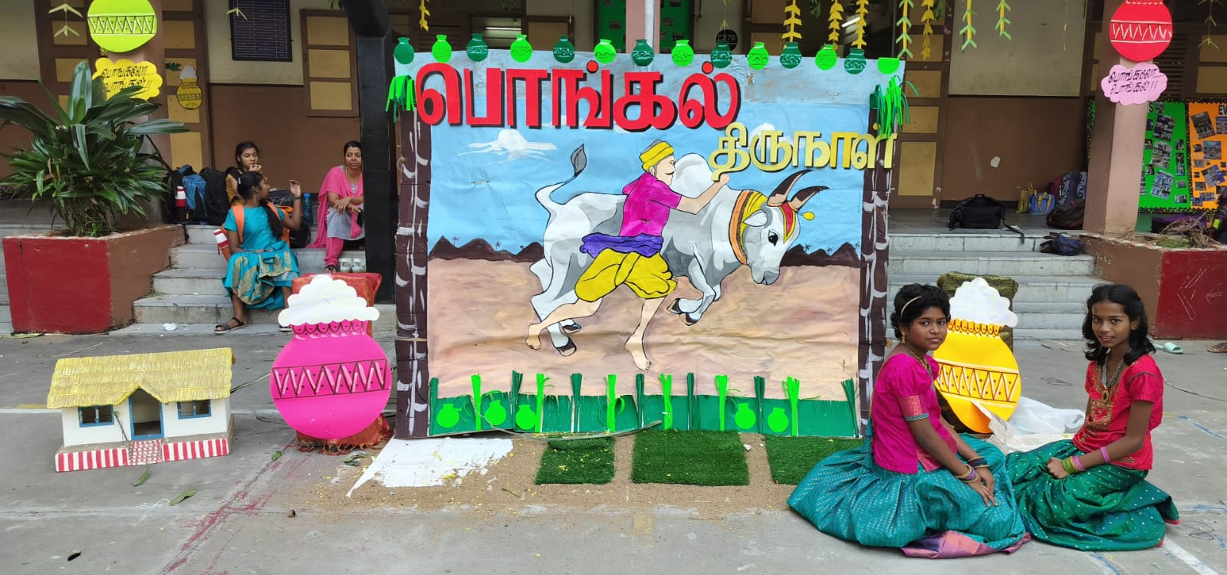
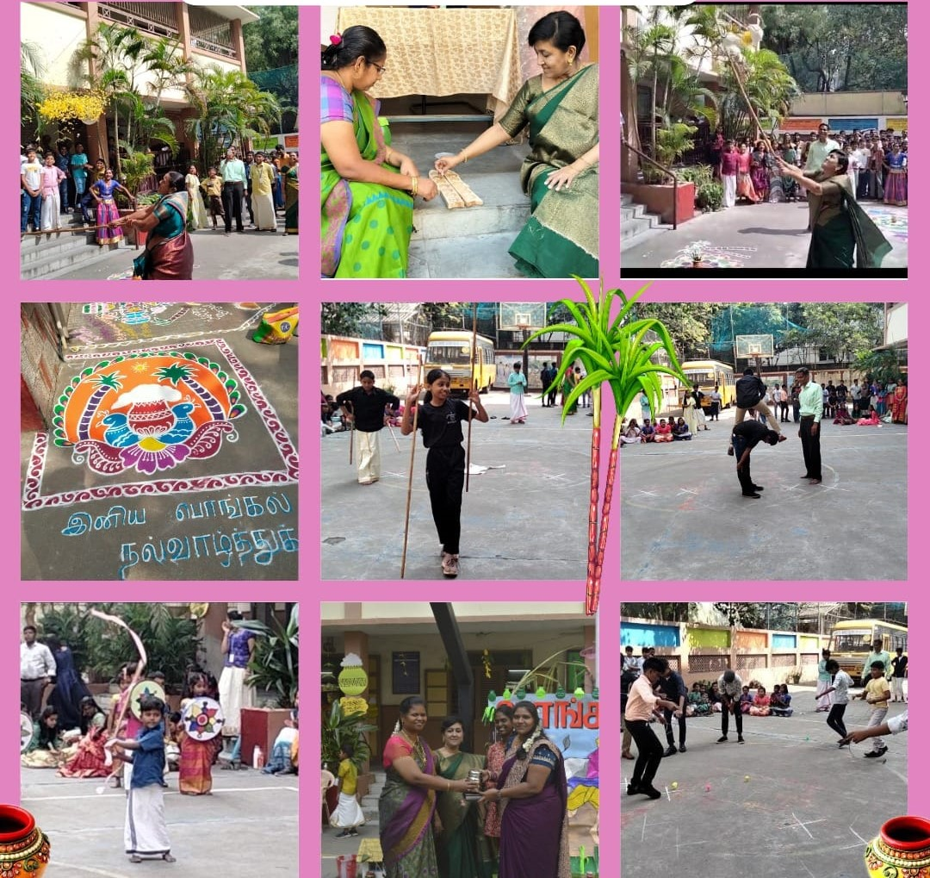

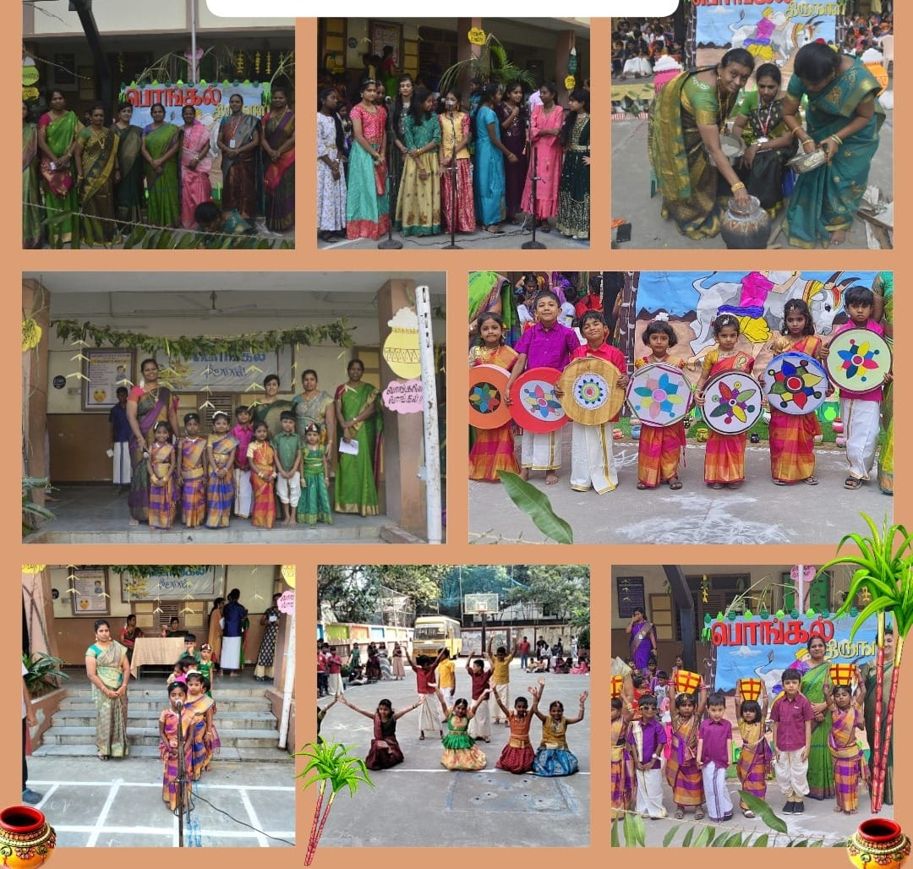
18.01.2024 – 27.01.2024
CATC CUM RD MARINA TRAG - II Camp was held at presidency College Chennai, from 18 Jan 2024 to 27 Jan 2024. Our students of Std 9 attended the Camp.
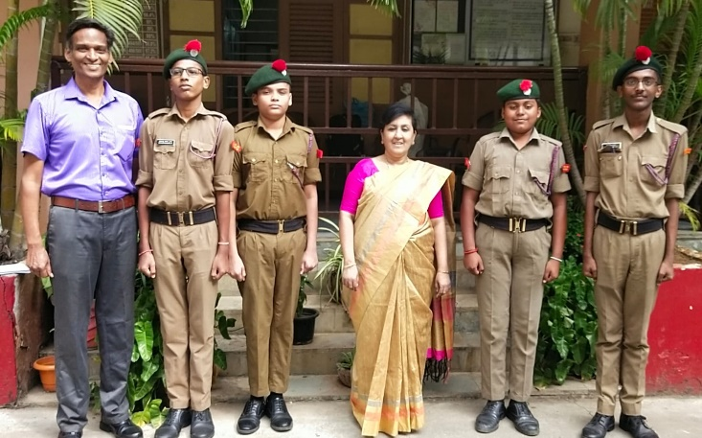
19.01.2024
Our school Annual Camp was held at Tonakela Camp, Ayyapakkam on 19.01.2024. The students of various ECA club attended the same and had various learning sessions and games.
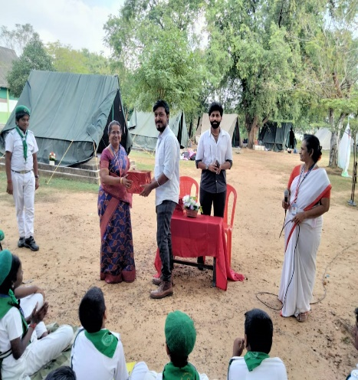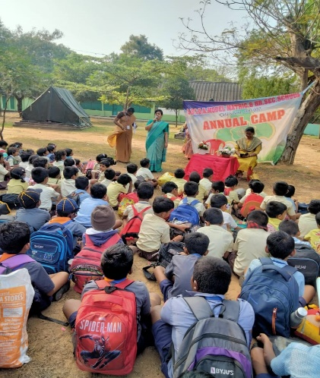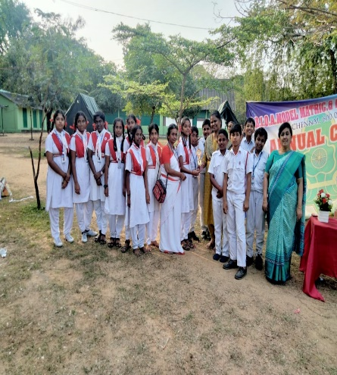

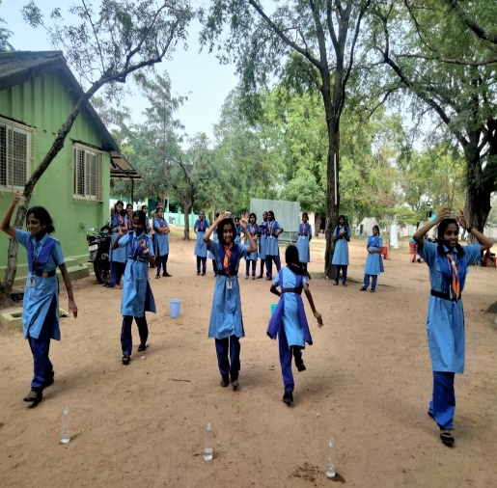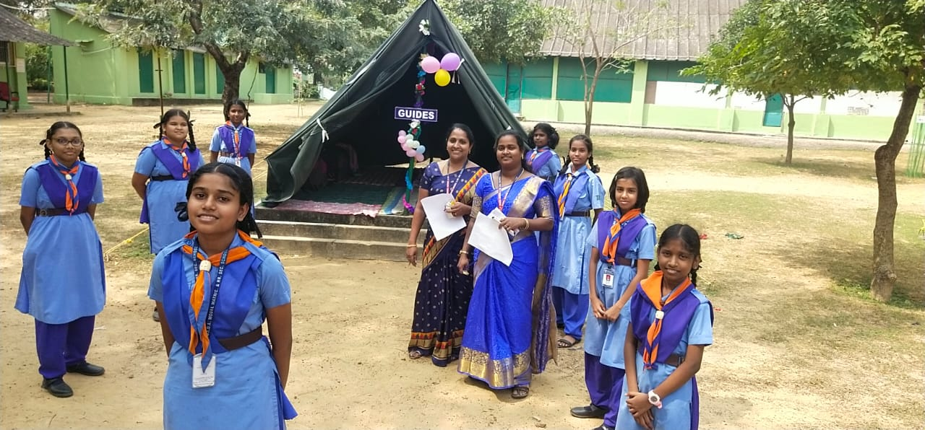
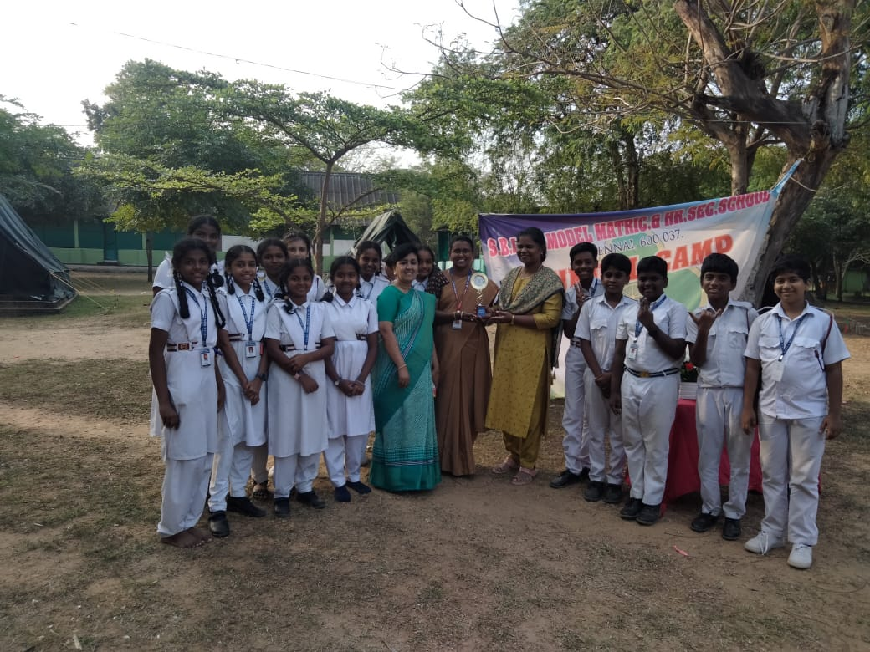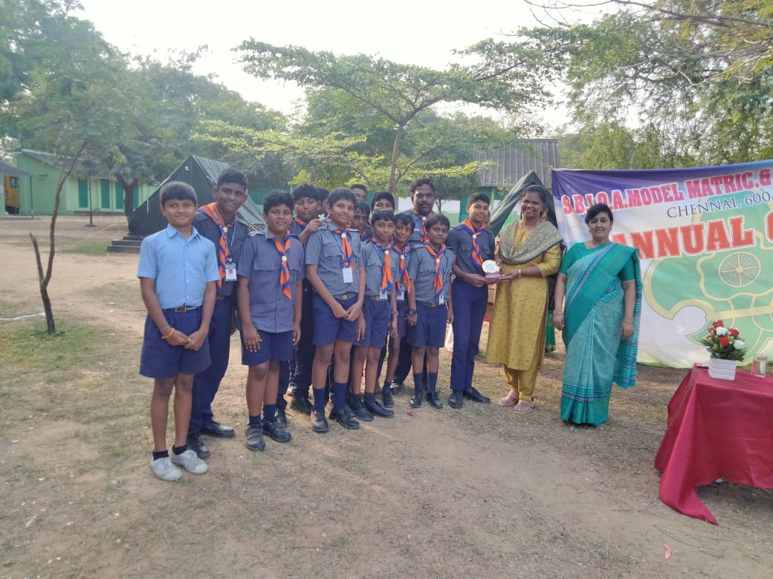
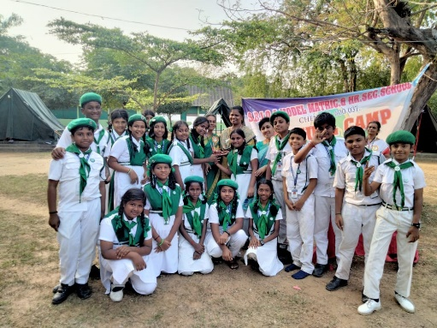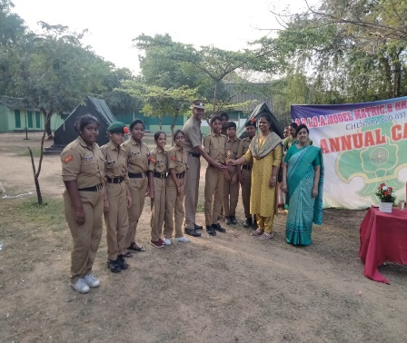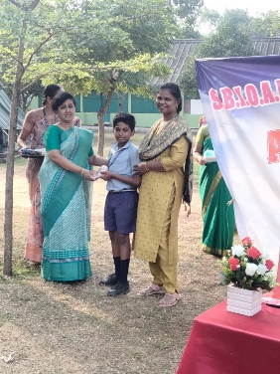
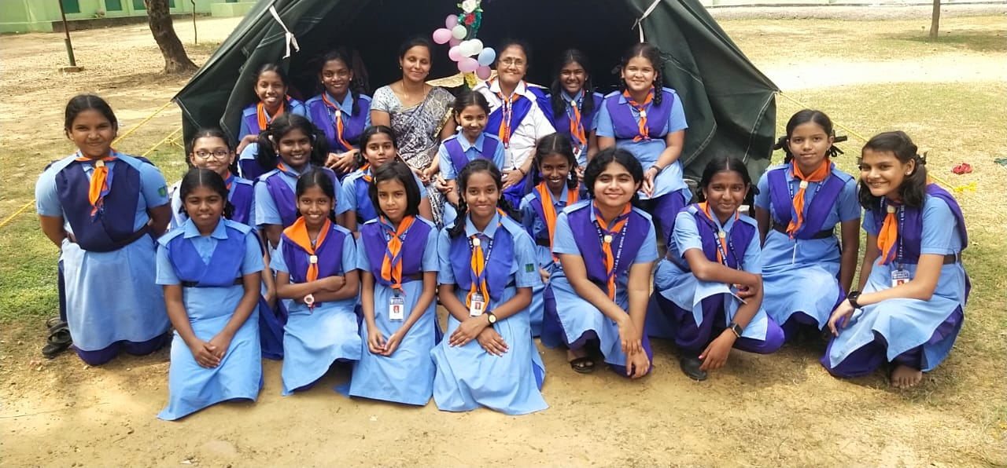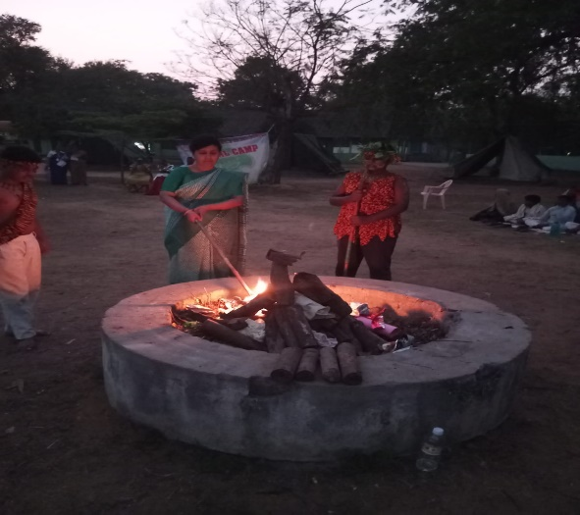
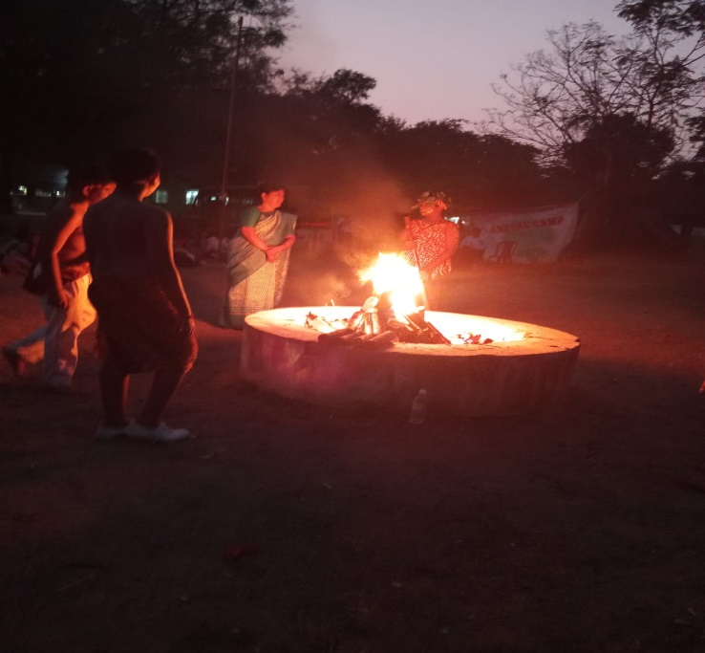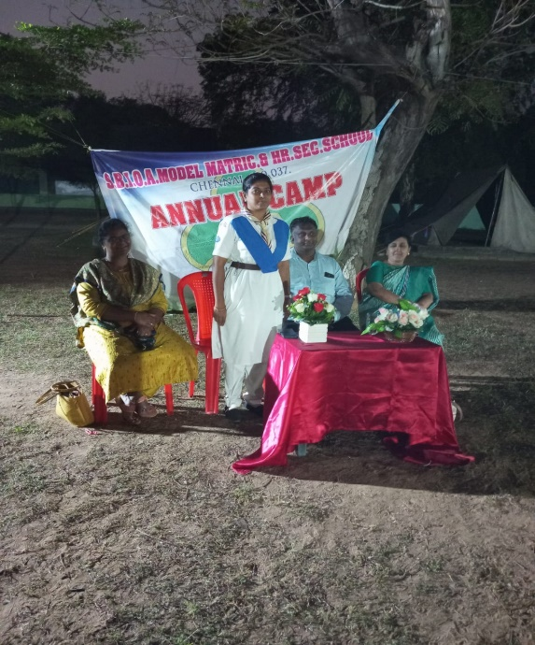
23.01.2024
A general and Dental checkup was held at our school promises from std LKG to IV. A Team of Doctors and Paramedical staff came from 4M Hospital checked the student’s health. A health card was given to the students for further follow up.
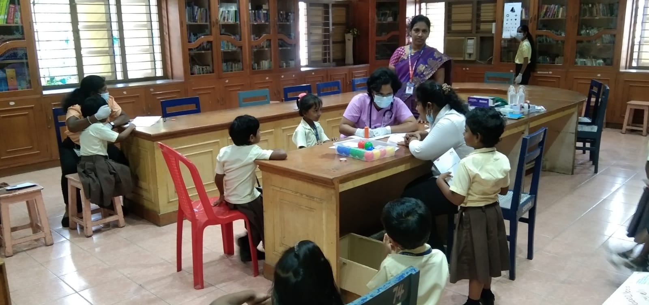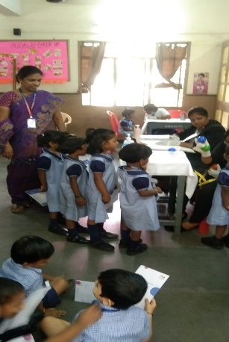
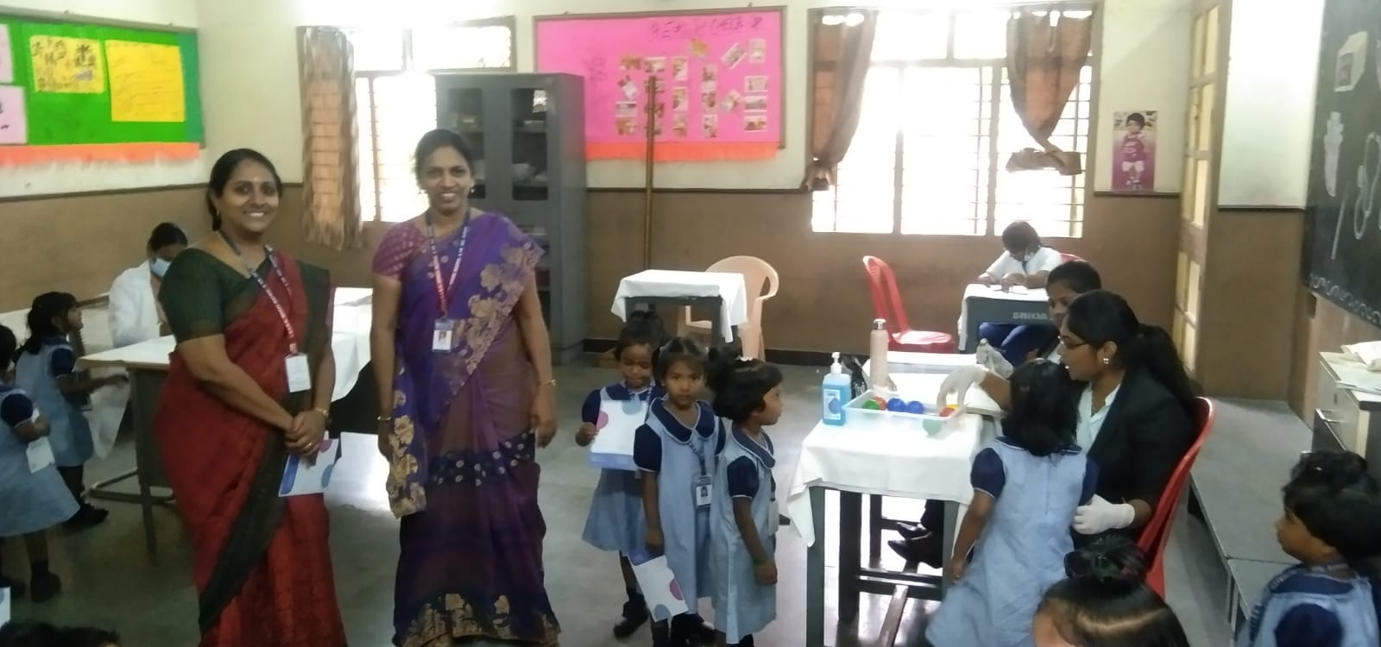
27.01.2024
A seminar for all the science teachers of various SBOA schools in Chennai was conducted at Global school on 27th January 2024. The resource person was Mrs. Sudha Malini who conducted a seminar on the topic “Science a way of life”. She spoke about teaching science to the students by igniting the scientific temper. The session was very lively with fun-based Activities to talk about favourite scientists and their impact on our lives. It was very informative to know the nuances of teaching science in different perspectives and had all of us spellbound.
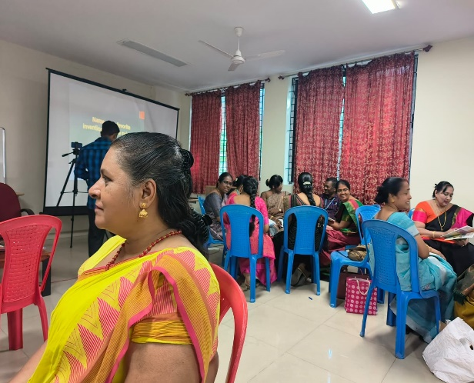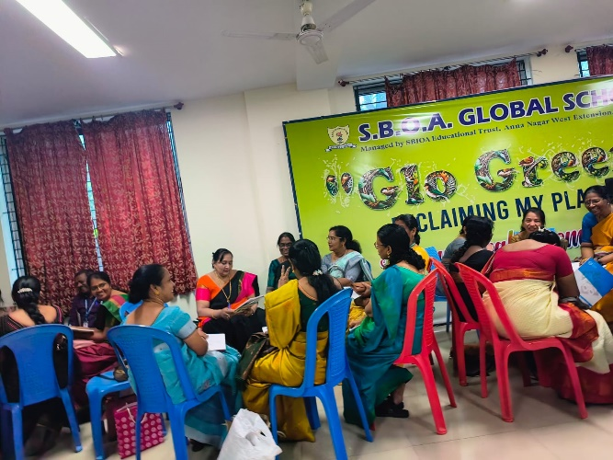
28.01.2024
Students of 12B attended the Accounting Wizard exam conducted by RR Academy on 7.01.2024. Nithyasree S and Rishwanth R got the Special prize and Future Accountant prize from the Academy on 28.01.2024.
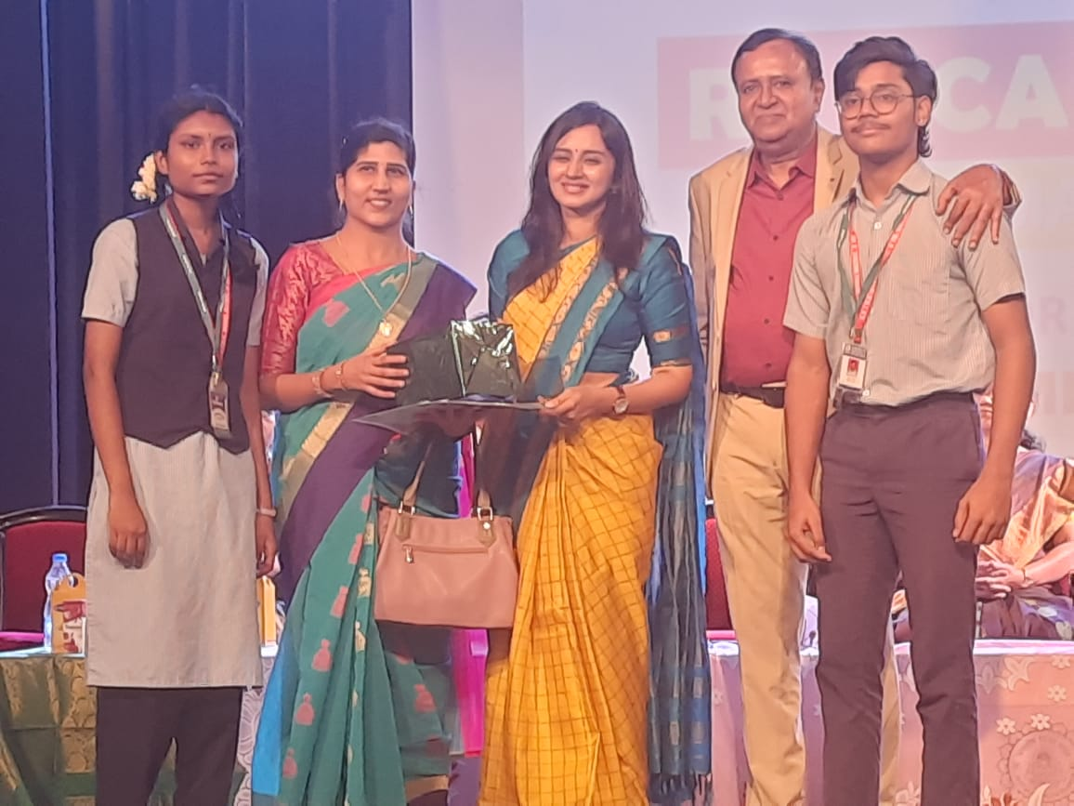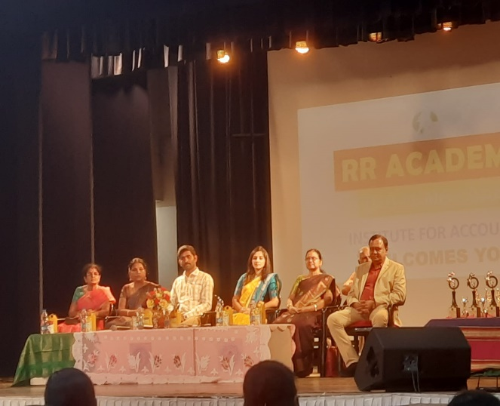

30.01.2024
Our school students took an oath against Untouchability with regard to Martyr's Day.
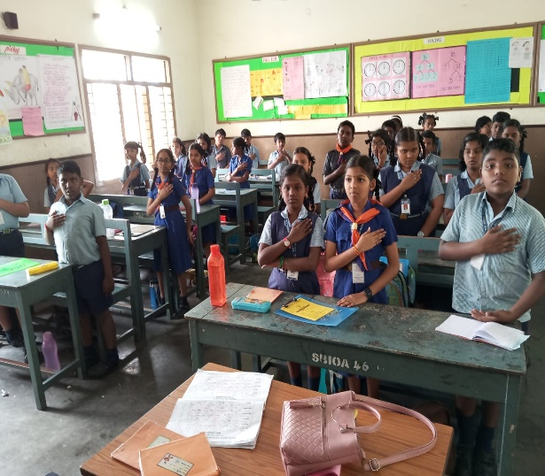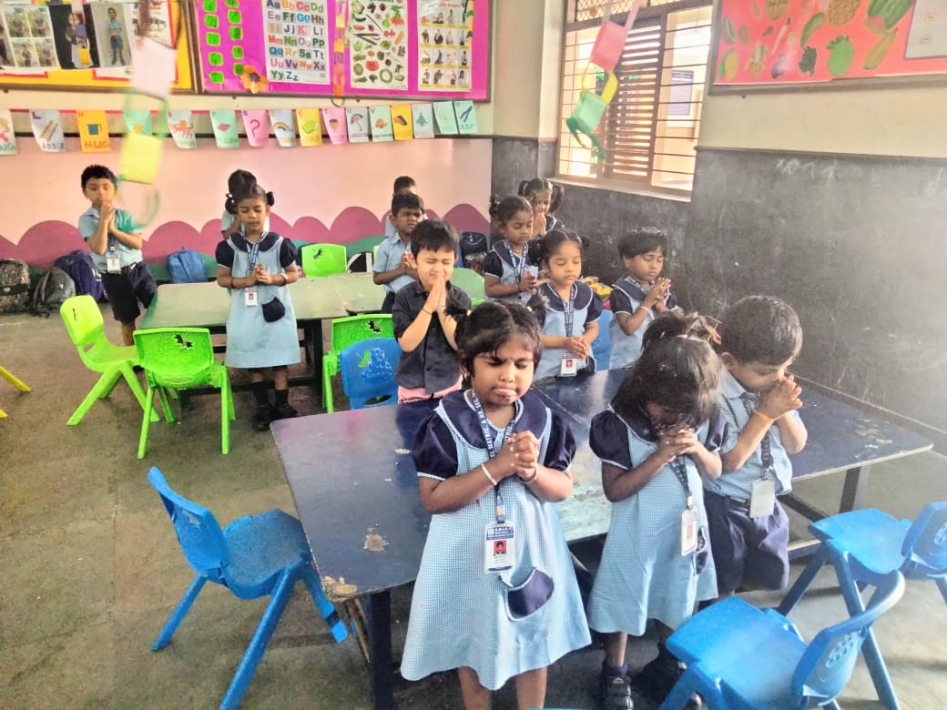
31.01.2024
Ion Tach Academy, Chennai conducted a Quiz competition Preliminary round for the Students of Std 3 - 9.
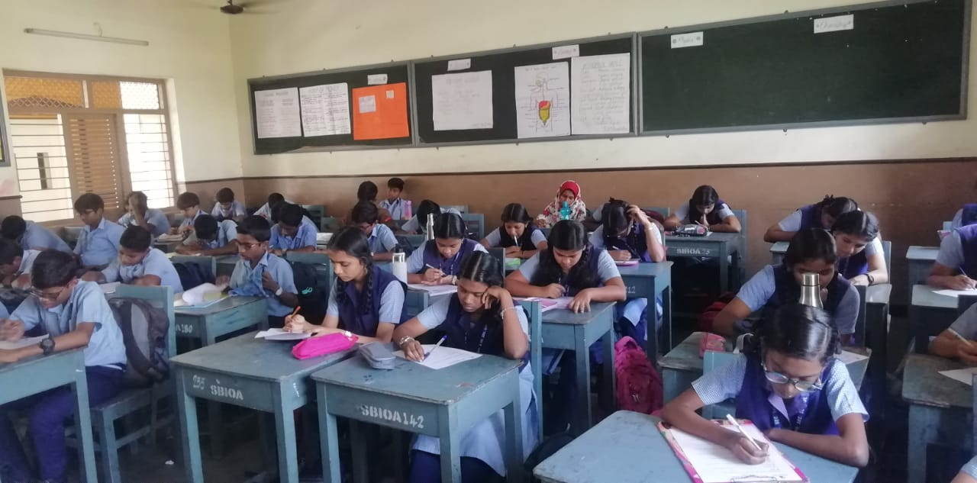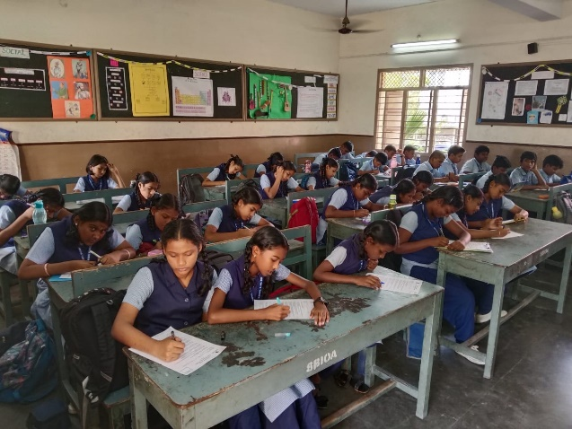
31.01.2024
An awareness programme on Road Safety was conducted for the RSP students at the auditorium.
