S.B.I.O.A. MODEL Matric. & Hr. Sec. School

Chennai 600037

# JUNE 2023



MONTHLY REPORT – JUNE 2023

**ACADEMICS**

**12.06.2023**

The School toppers of Std X, XI and XII were honoured by the Correspondent, Mr. P. Mohan. The NCC cadets who participated in the ATC 2023 at BS Abdhur Rehman Cresent Institute of Science and Technology, Vandaloor received the certificates.

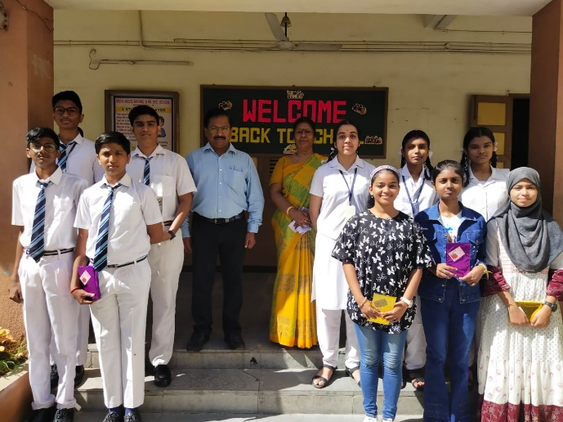 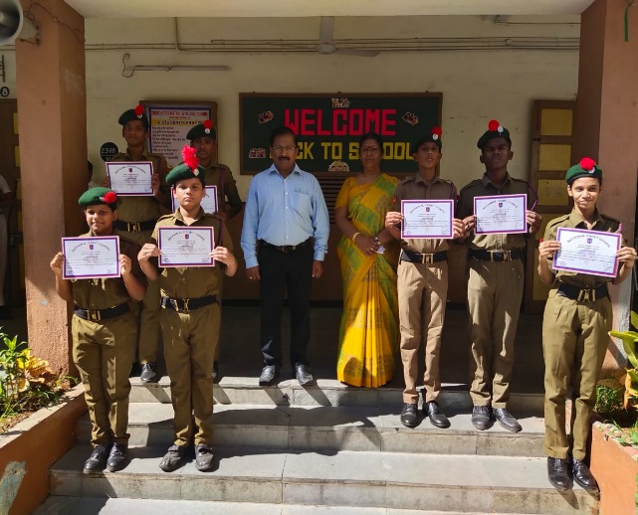

**15.06.2023**

The Headmistress honoured the toppers, the Centum scorers of Std 1 – 9 and students who were100% attendance with smiley badges in the assembly.

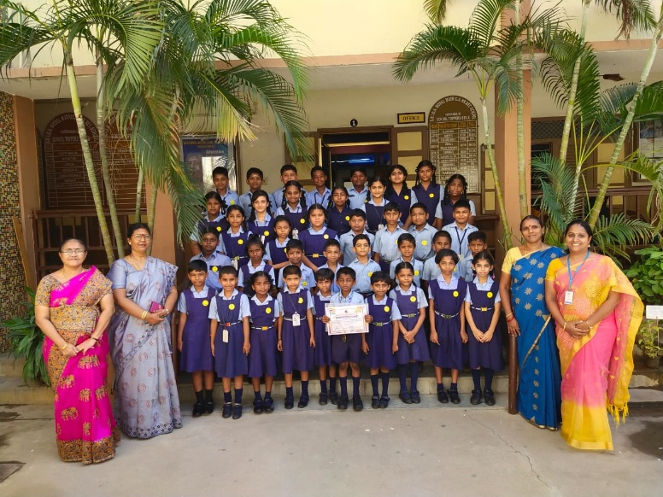 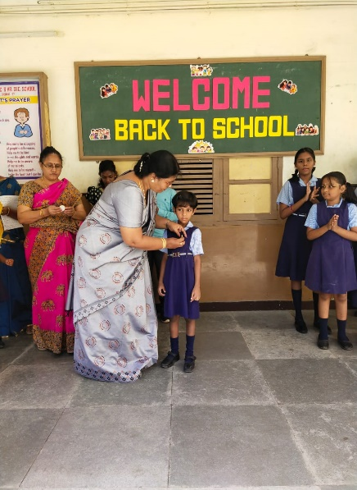

**ACHIEVEMENTS**

**17.06.2023 & 18.06.2023**

The 9th SDAT Dolphin State Level Short Courses Age Group Aquatic Championship was held at SDAT Dolphin, Mogappair. Subhiksha K.S. of Std VI-A secured a gold medal in 100mts free style, 4*50mts Freestyle, 4*50mts Medley relay and a Silver medal in 50mts free style.

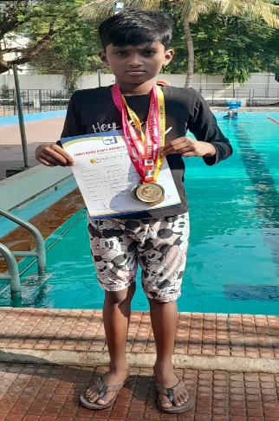

**EVENTS & EXTRA CURRICULAR ACTIVITIES**

**07.06.2023**

Mr. P. Mohan, Correspondent took incharge as the Correspondent of S.B.I.O.A. MODEL Matric. & Hr. Sec. School.

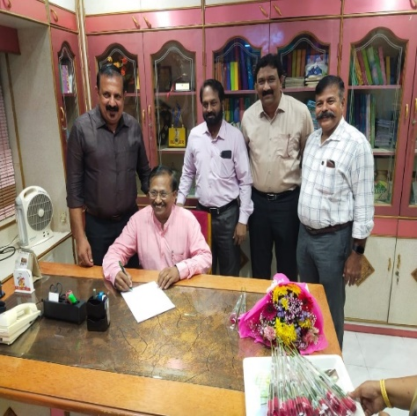 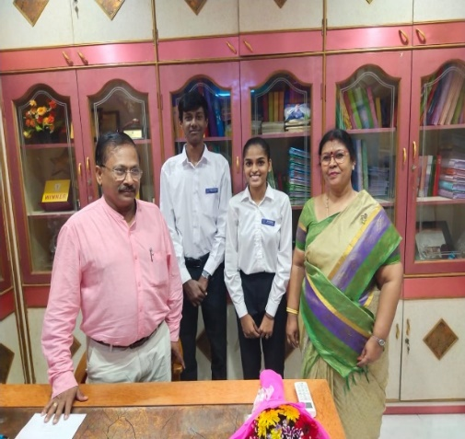

**14.06.2023**

Students of Std VI were briefed about Child Labour Day and created awareness among children to know about social justice that all children should have the right to education.

Students were encouraged to write slogans and draw in order to create awareness about Child Labour Day.

Values learnt during the activity: Team work, creative thinking and gratitude. They were made to feel how blessed they are to have education.

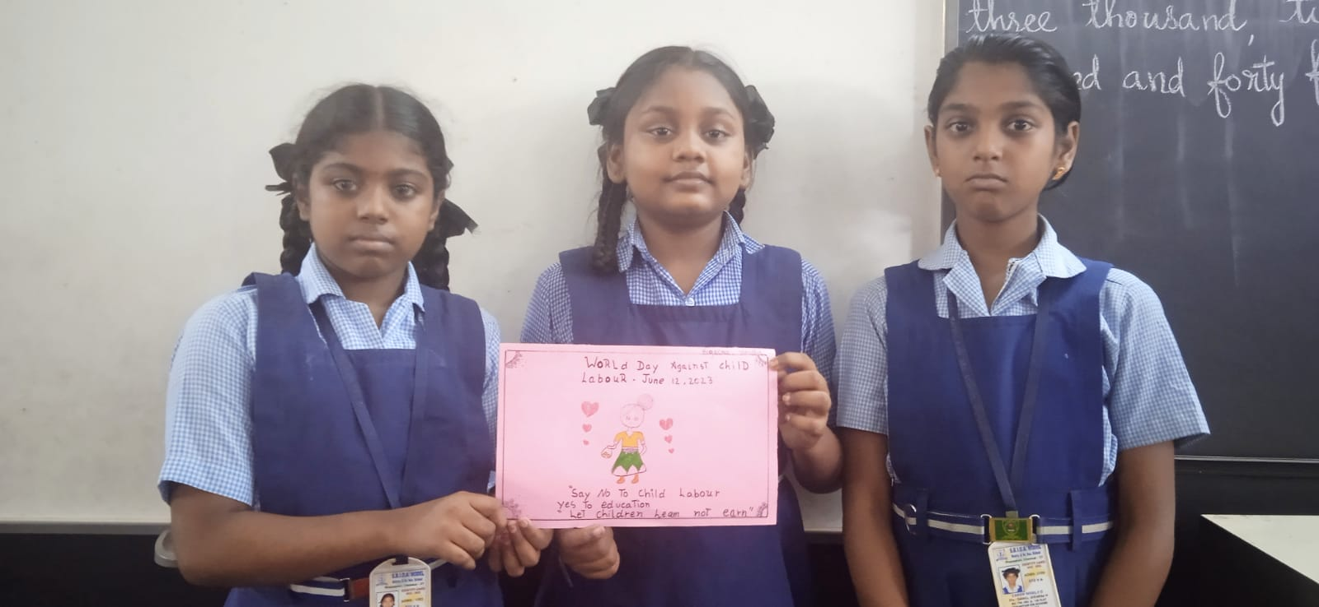

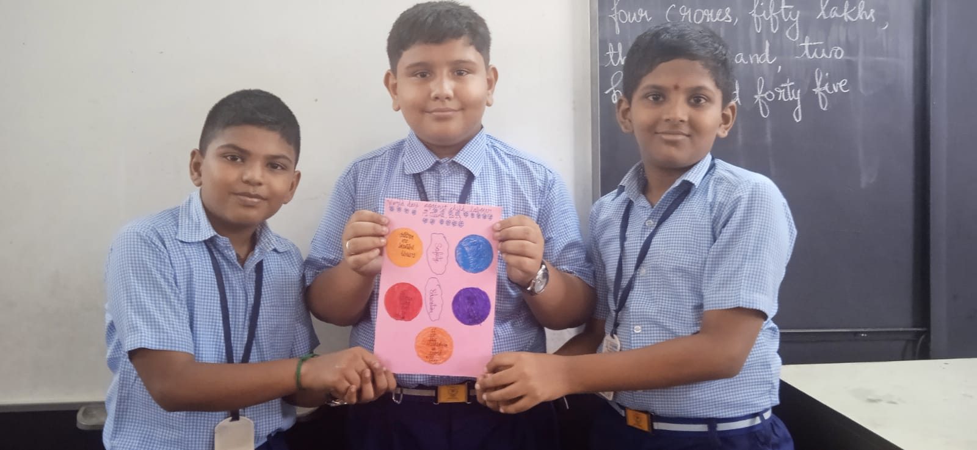

**21.06.2023**

Yoga Day was observed on 21st June 2023. Our Correspondent inaugurated the programme and he spoke about the importance of yoga in day-today life. The event started with Tamizhl thaai vaazhthu and the Headmistress welcomed the Correspondant and the students. Yoga demonstration started with a warmup. Children performed yogasanas and breathing exercisesand ended with relaxation.

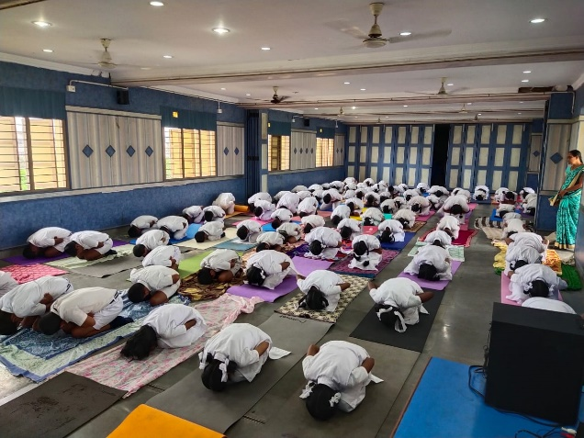 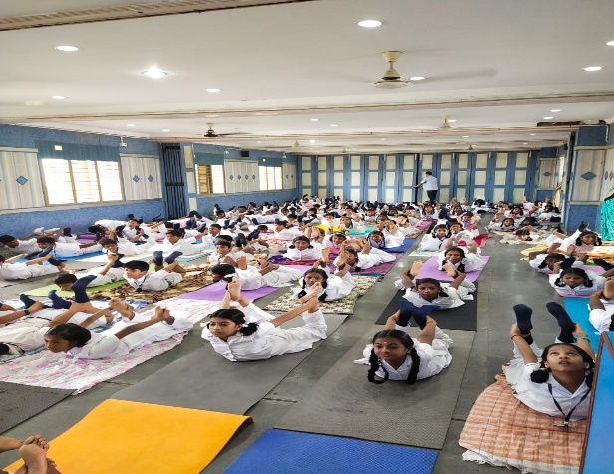

**28.06.2023**

Thamizh Illakiya Mandram was organised on 28th June. The programme was inaugurated by the Headmistress Mrs. Georgina Premkumar. Oratorical competition was conducted for the of Std XII. The children spoke on the topic ‘ Whose Education is the best- Girls or boys’. The judges were Mrs. Sornambigai Ravi and Mrs. P.S.Bindhuja. All the students were appreciated and the prize winners were honoured.

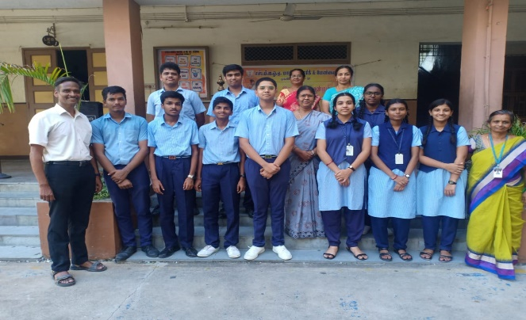  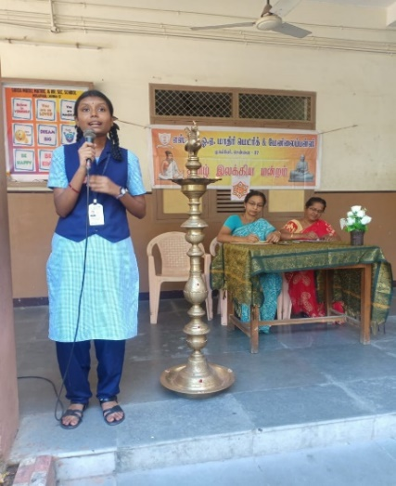

**30.06.2023**

Investiture Ceremony for the Academic Year 2023 – 2024 was held with great pomp and dignity in a special ceremony at the School ground. The event was presided over by Mr.P.Mohan, the Correspondent. The Headmistress Mrs. Georgina Premkumar delivered the welcome address. The Correspondent invested the leaders of the Student Council and the class monitors with badges. The Head Boy, Arunkumar R. of Std XII – A proposed the vote of thanks.

