**S.B.I.O.A. MODEL Matric. & Hr. Sec. School**

Chennai 600037

# JUNE 2024



**MONTHLY REPORT – JUNE 2024**

**ACADEMICS**

**01.06.2024**

The Headmistress, Mrs. Asha Robinson introduced the new Correspondent, Mr. Anbarasu R. The teachers had a meeting with the Correspondent. He motivated the teachers and had a discussion with them about how we can make our school reach greater heights.

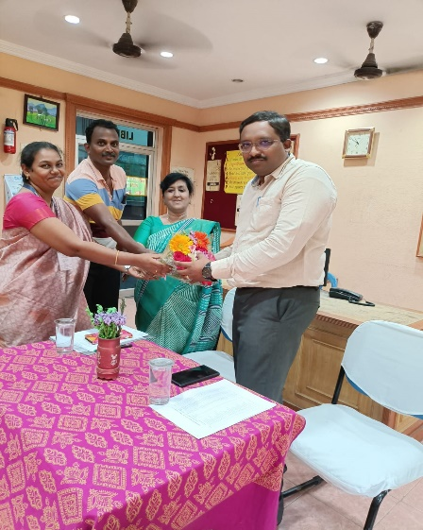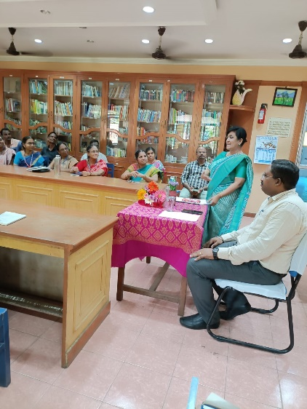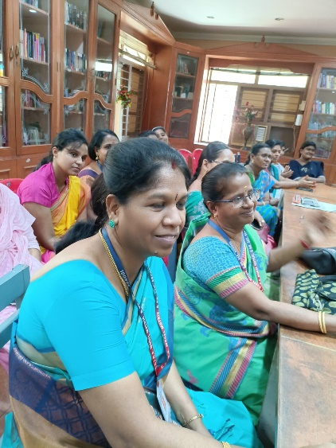

**10.06.2024**

The toppers of Std X and XII were honoured with a shield in the assembly by our Correspondent.

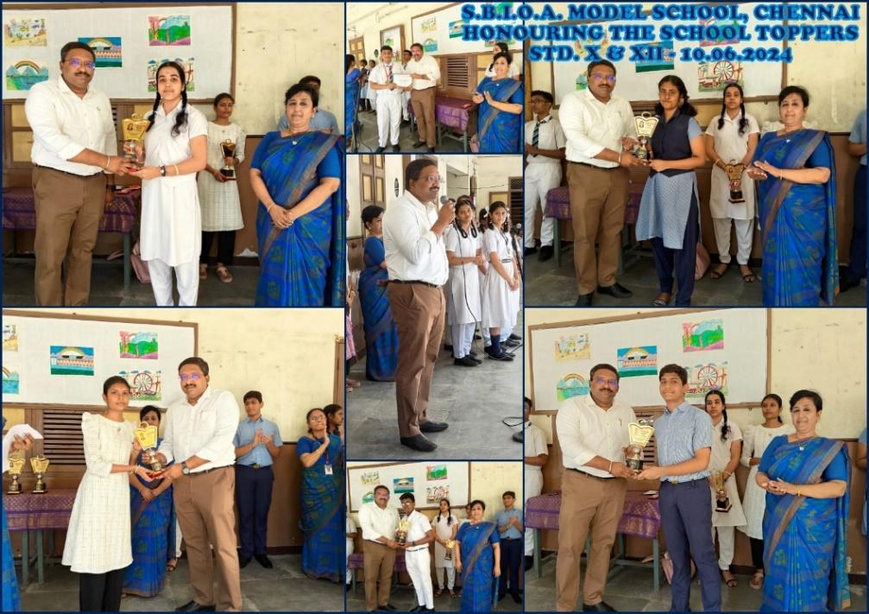

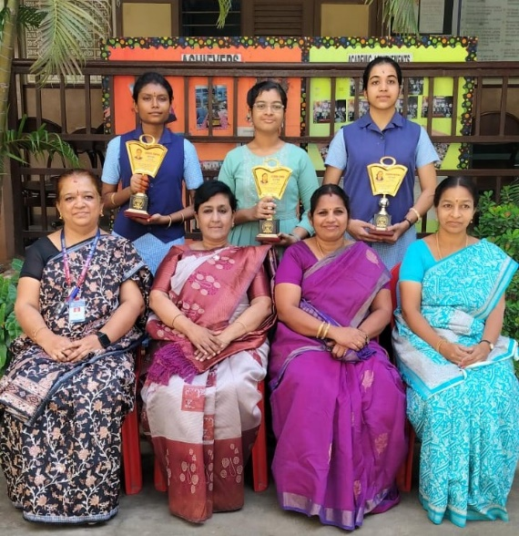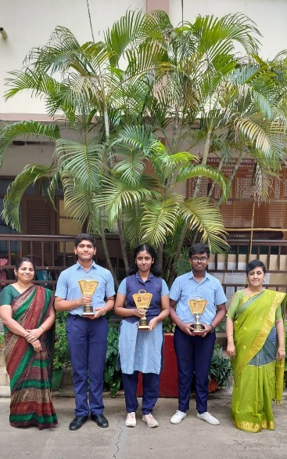

**22.06.2024**

The Orientation programme for the new teachers was held at SBOA JC on 22.06.24. The newly recruited teachers from our school attended the same. The President of the SBIOA Educational Trust, Dr. Nithish Andreyya Raja Singh, delivered the Presidential address and the Secretary and Correspondent, Shri A. Senthil Ramesh, gave a keynote address through Google Meet. The Administrator of the SBIOA Educational Trust, Mr.V.V. Anand spoke about the history of the SBIOA Educational Trust, mentioning the names of the primary office bearers. He then shared the important information about the 13 schools run by the Trust. Following this, he outlined the rules and regulations of the management and highlighted the benefits of the trust, providing a clear idea about the pay scale.

The Administrator, Mr. D. Ravi Kumar, highlighted the rules and regulations of the SBIOA Educational Trust by discussing the points mentioned in the appointment order. Additionally, he included a few more points that were not mentioned in the appointment order.

In the next session, the Resource Person, Mrs. Sabural Banu Ibrahim, Principal SBOA Mat. Hr. Sec. School talked about the Goal setting and how it is important for a teacher to have focus and targets in their teaching. The session included many group activities.

The next session was taken over by Mrs. P. Gomathi, Asst. Headmistress of SBOA JC. The topic was ‘Role of Technology’ in today’s education. She spoke about the importance of teachers being proficient in technology to effectively compete with AI Robot teachers. She demonstrated a few concepts on how they can be explained through technology and how teachers can create their own presentations to enhance their teaching methods. She also listed applications that can be used in teaching.

The final session was taken over by the Resource Person Mrs. Asha Robinson, Headmistress, SBIOA Model School. She spoke about ‘Teaching methodologies and Lesson plan writing’. She started the session with a fun activity. She then shared methodologies that can be used in teaching to fulfil the needs of all kinds of students in a classroom. She explained the important notes to be included in the lesson plan and provided a worksheet for them to write a sample lesson plan.

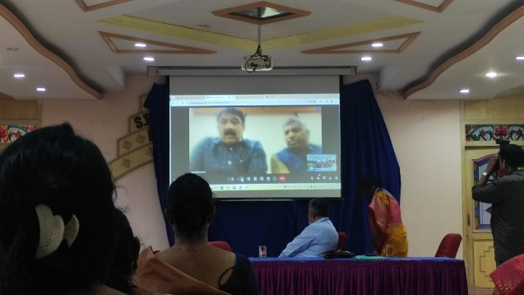 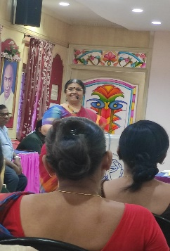 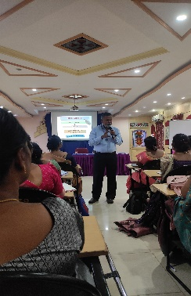

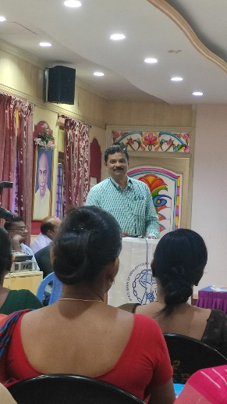 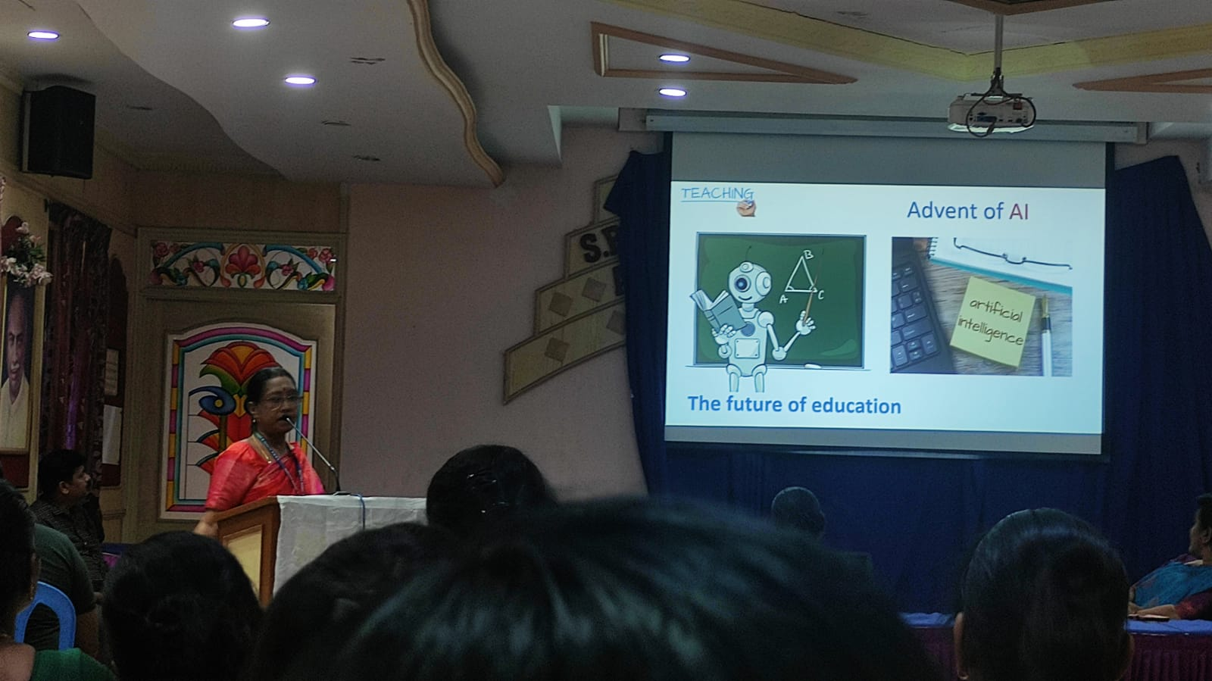

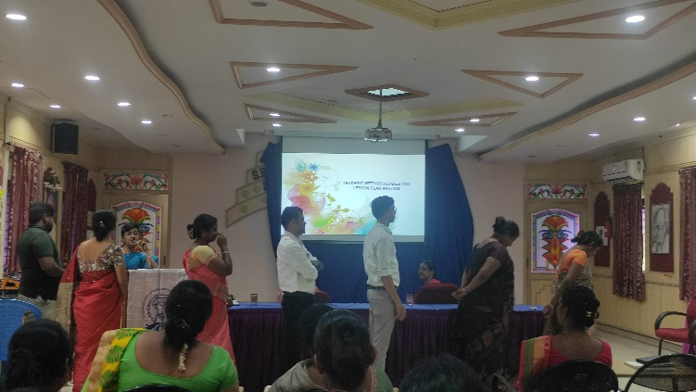 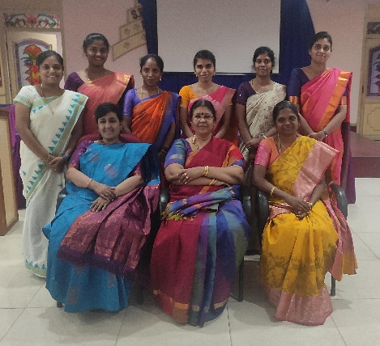

**24.06.2024**

Internal Assessment for Std IX to XII commenced on 24.06.2024.

**ACHIEVEMENTS**

**28.06.2024**

Revant R. of XII A participated in the UNITED Muay Thai Association of Tamil Nadu (UMAT) State Muay Thai League Championships held on 10 & 11th May at Chennai Trade Centre Ramapuram, Nandambakkam, Chennai, organised by Sri Muay Thai Boxing Academy and he won the gold medal.

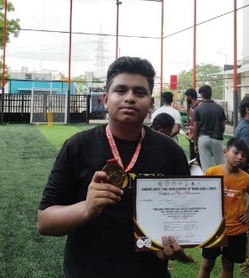

**20.06.2024**

Dushyanth J. of Std III participated in All India Boxers Promotion Boxing Competition – 2024 held on 17, 18 & 19th May and he won the gold medal.

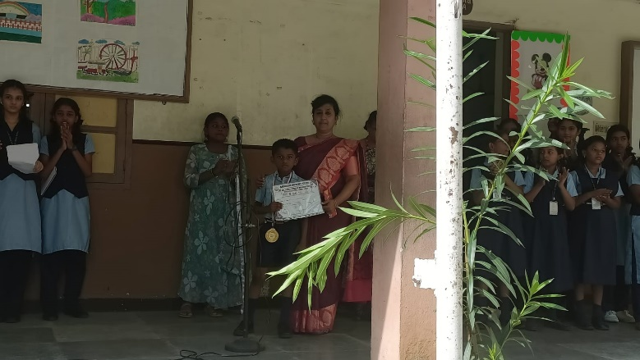

**29.06.2024**

The Headmistress Mrs. Asha Robinson received the "Distinguished Principal Award" from RAMS Business Analytics Ltd on 29.6.2024 at Shree Akshayam Hotel, Velachery.

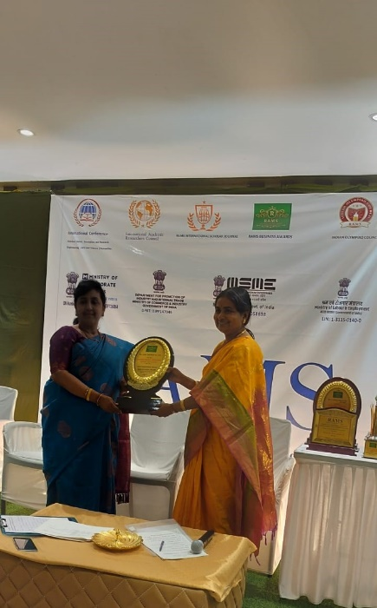 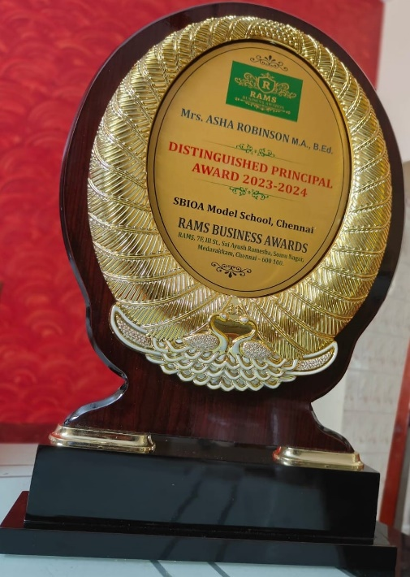

**EVENTS & EXTRA CURRICULAR ACTIVITIES**

**05.06.2024**

World Environment Day was observed on 05.06.24. The Correspondent, Mr. Anbarasu R. initiated the Tree planting ceremony followed by the Headmistress and the teaching faculty in our school campus.

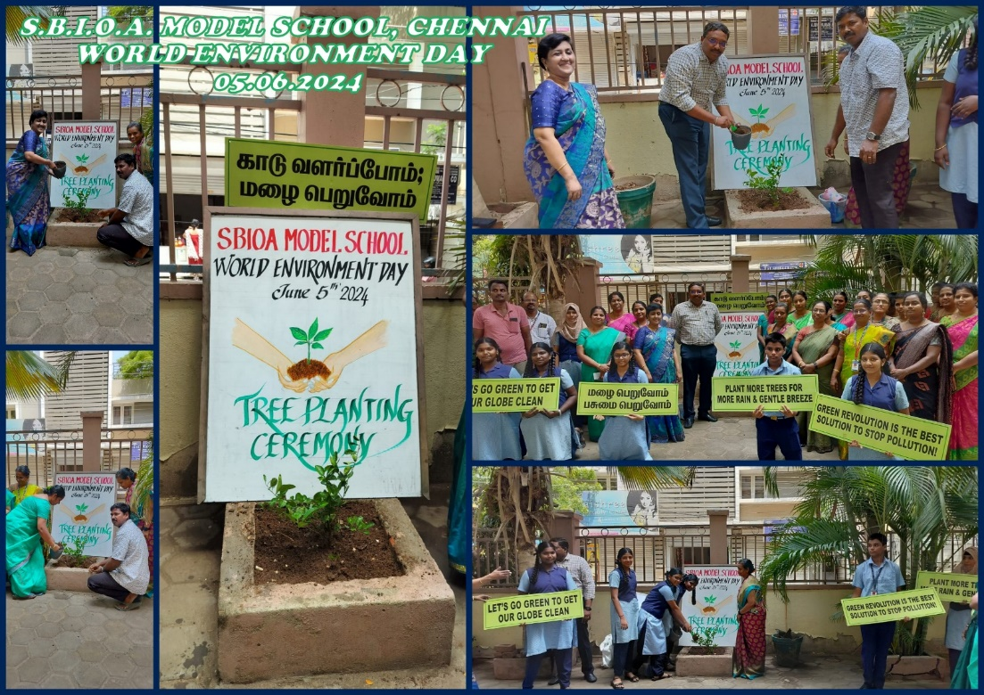

**10.06.2024**

The Orientation Programme for Std XI was held on 10.06.24 at the auditorium. The program started with prayer song followed by the welcome speech given by Mrs. Hemlata Venkatesan. The Correspondent Mr. Anbarasu R. addressed the gathering with a positive thought and encouraged the students by his motivational speech. The Headmistress Mrs. Asha Robinson addressed the gathering by her exploring thoughts and she introduced the class teachers and the subject teachers of XI A and XI B to the parents and students. The Academic Supervisor, Mrs. Radha Suresh instructed the students briefly about the rules and regulations of the school. The Chief guest Mr. Robinson, Sub-Inspector of Police, Nolambur interacted with students for their new beginning of life with his thoughtful advices. Vote of thanks was given by Mrs. Hemlata Venkatesan and the program successfully ended with the National Anthem.

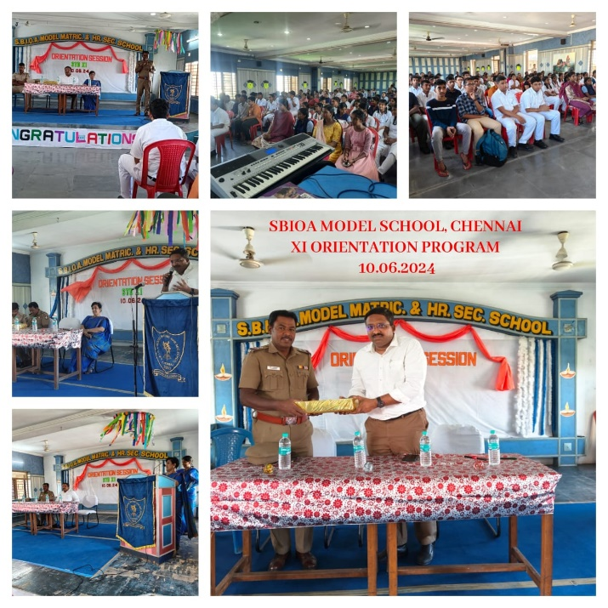

**12.06.2024**

The Department of Kindergarten conducted the Orientation programme for LKG children on 12.6.2024. Parents along with the children were asked to assemble in the school library at 9:00 a.m. The orientation started with "Tamilthai Vazhthu”. Mrs. Asha Robinson, our Headmistress further elaborated the instructions which are to be adhered. She introduced our Academic Supervisor, PTA President and also all the teachers who are handling LKG. As the token of remembrance, sapling was presented to all the children. Finally, the instruction paper and biodata forms were given to the parents.

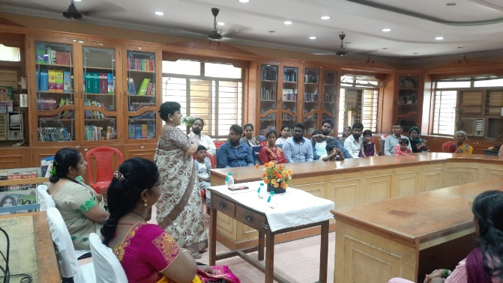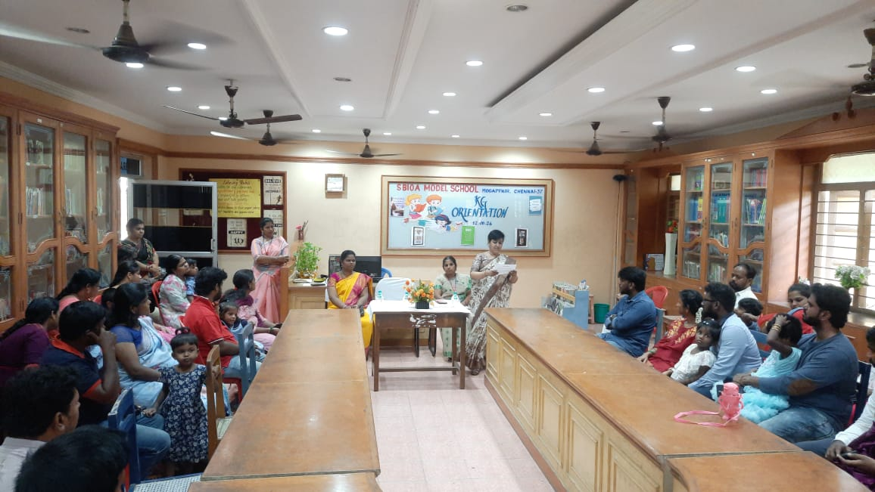

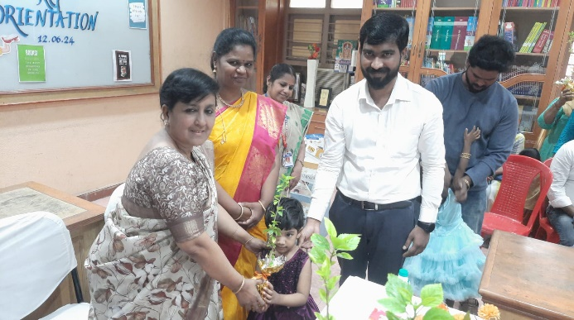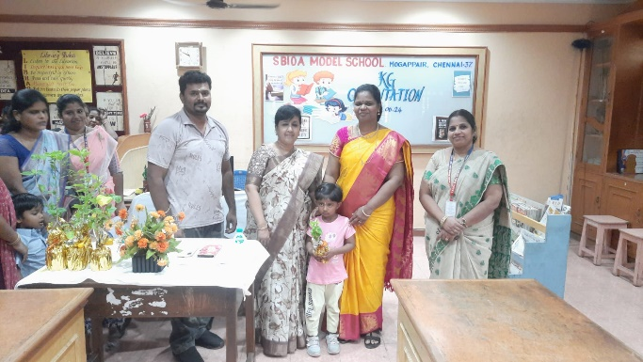

**21.06.2024**

International Yoga Day was observed on 21.06.2024 which was led by Mr. R. Balasubramanian. Std 8th and 9th children attended the session and were enthusiastic about it.

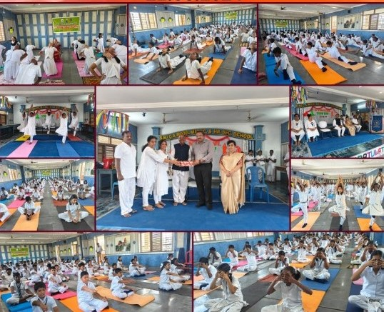

**24.06.2024**

Drug Abuse Awareness program was conducted for the Students of Std IX to XII. Mr. Robinson, Sub-Inspector of Police, Nolambur addressed the children about avoiding drugs and to keep ourselves safe from the dangers and ill - effects of drugs.

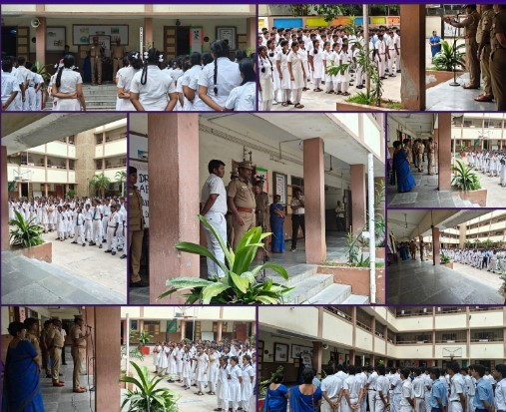

**27.06.2024**

The inauguration of Tamil Ilakiya Mandram was done by our Headmistress Mrs. Asha Robinson on 27.06.2024.

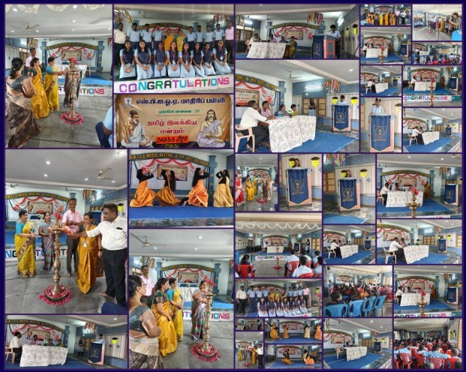

**27.06.2024**

We had a special assembly for KG children. The UKG children welcomed the little stars of LKG for the academic year of 2024 -25. They did one special song (Happy), welcome dance and Analia Esther of UKG delivered a special speech on welcoming the little Stars. The Headmistress spoke with the little kids jubilantly.

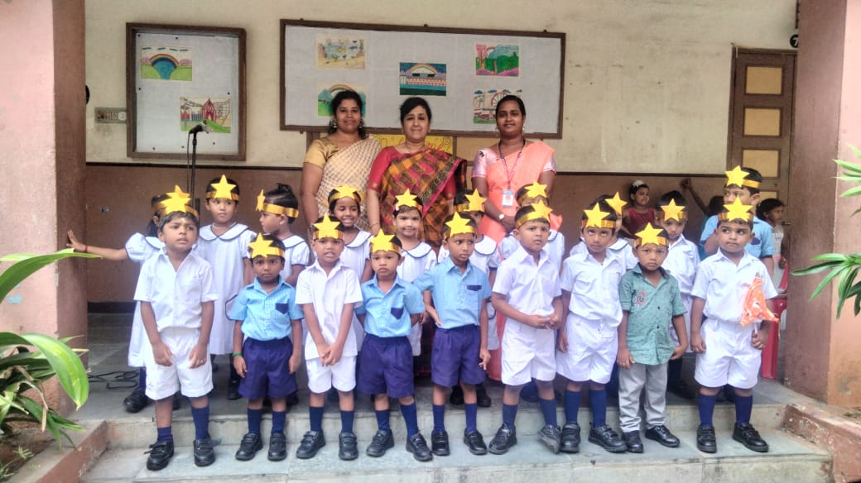

**28.06.2024**

NCC enrolment was done for the students of Class VIII. Mr. Babulal Thirunavukarasu had done the enrolment of the children.

