

S.B.I.O.A. MODEL Matric. & Hr. Sec. School,

Chennai - 600037

MARCH 2024

MONTHLY REPORT march 2024
ACADEMICS
Board exams were held for Std X, XI & XII.

ACHIEVEMENTS
O8.03.24
Our school Accountant Mr. Robin was honoured by SBOA Matric School, Anna Nagar on 08.03.24 for having helped the school with fee determination work.

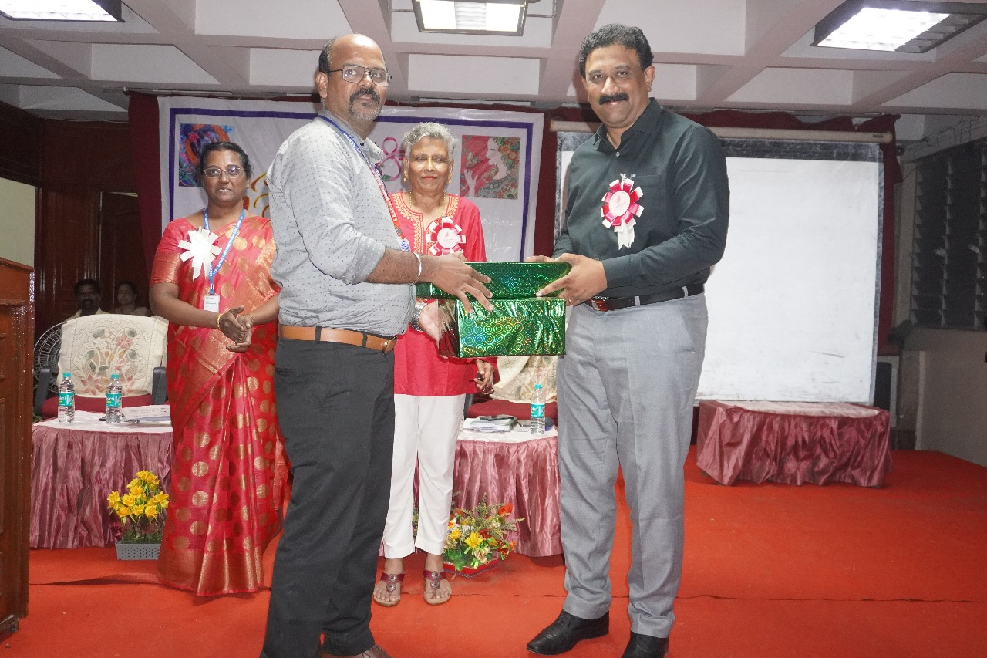
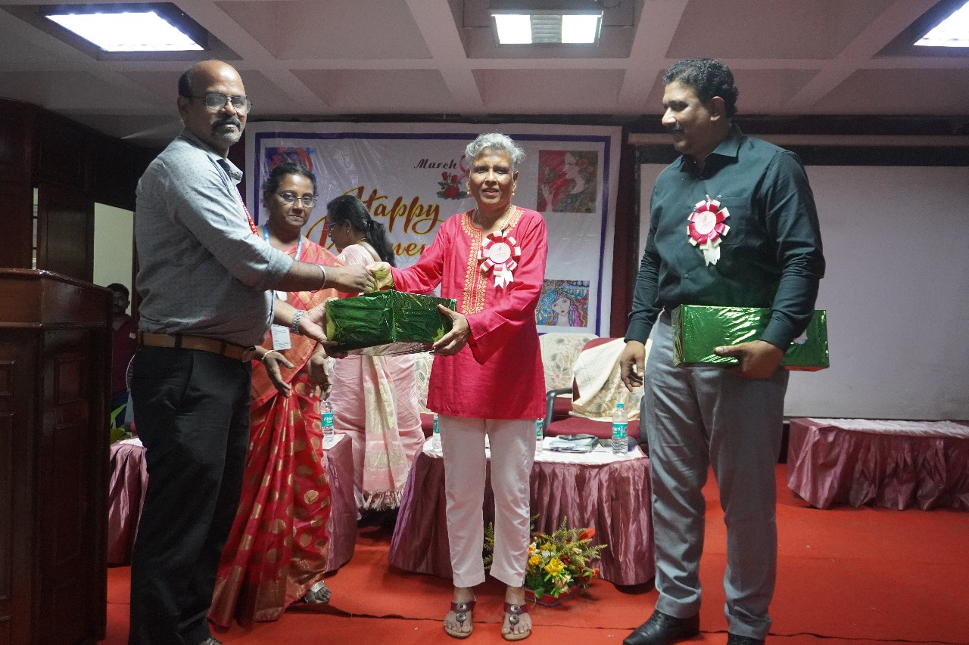
17.03.24
On 17.03.24, JSW Paints in association with The Hindu Young World conducted Future Scapes Painting Competition at the regional level. Around 250 students took part in it. Our school students, Subbulakshmi of Std IX, Dhaniha L. of Std VII and Jeevasri D. of Std VI B were qualified for the Regional level. Jeevasri D. of Std VI B received a consolation prize.
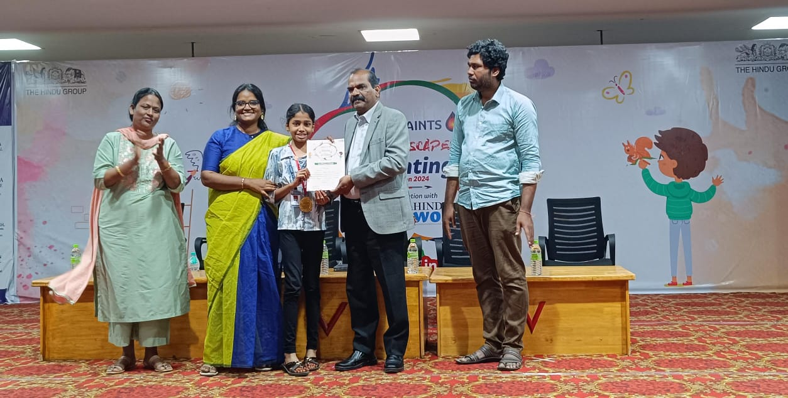
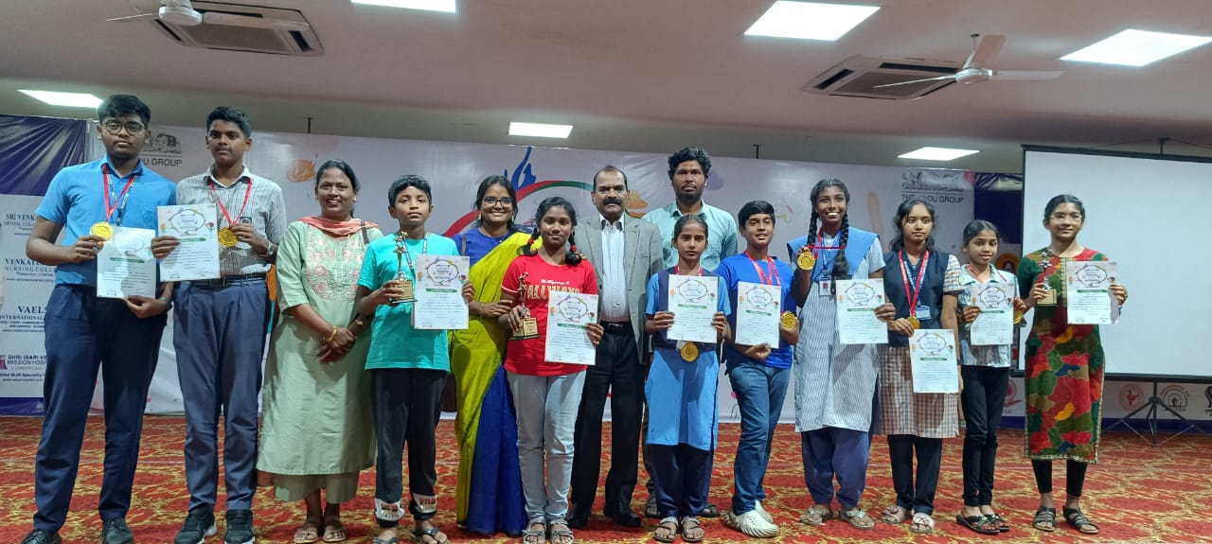
EVENTS & EXTRA CURRICULAR ACTIVITIES
02.03.2024
On 02.03.24 in our school premises, COOKING WITHOUT FIRE COMPETITION was conducted for the students of classes 6th, 7th, 8th. All the competitors actively participated and made delicious food items.
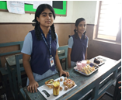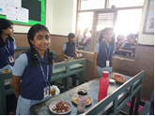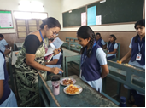
08.03.2024
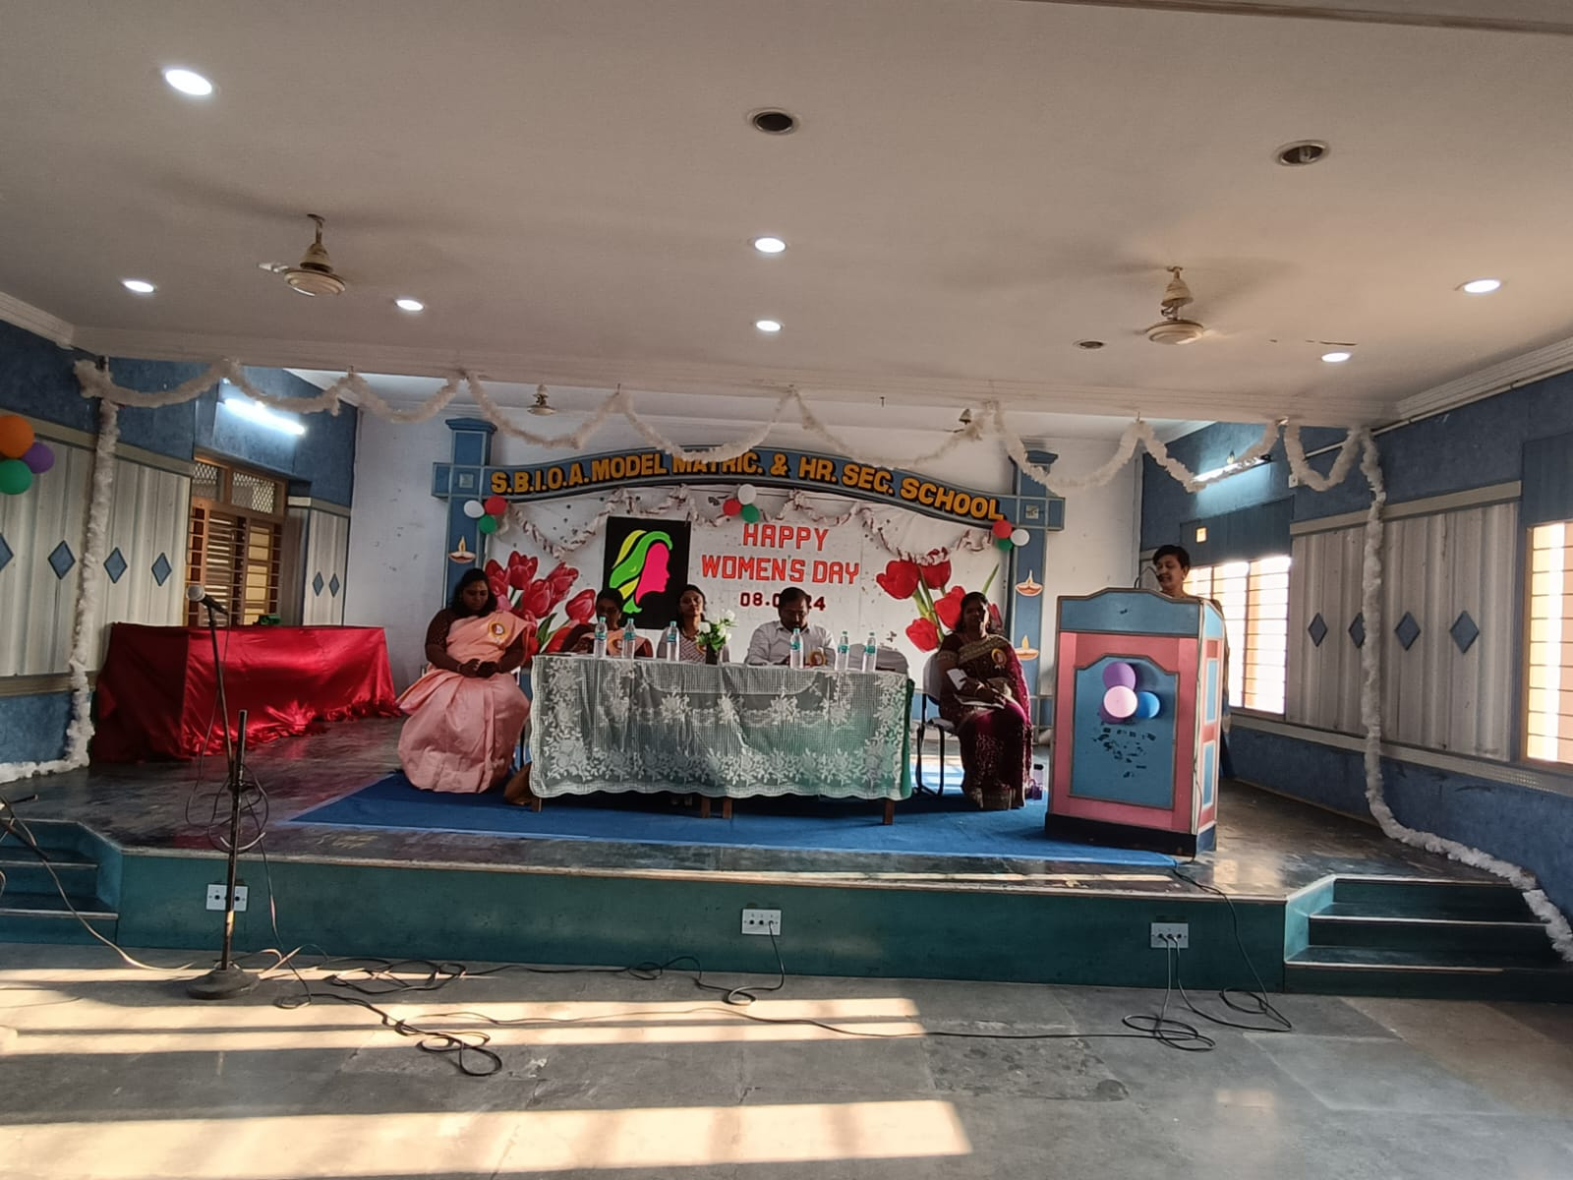
On 08.03.2024, WOMEN’S DAY celebration was held at the auditorium. Dr. Chitra Aravind, Consultant Psychologist, Founder of MANAS was the Chief Guest. In her address to the staff, she offered words of wisdom, suggesting that acceptance is the key to peace of mind. Our Correspondent, Shri P. Mohan wished all the women staff and presided over the function. Mrs. Shanthi, Associate Secretary, SBIOA Educational Trust gave a special address. Mrs. Akila, Deputy Treasurer and Management Committee Member graced the occasion. Our PTA President, Mrs. Sylvia Shobana delivered a special address. Our staff entertained the audience with their electrifying performance.
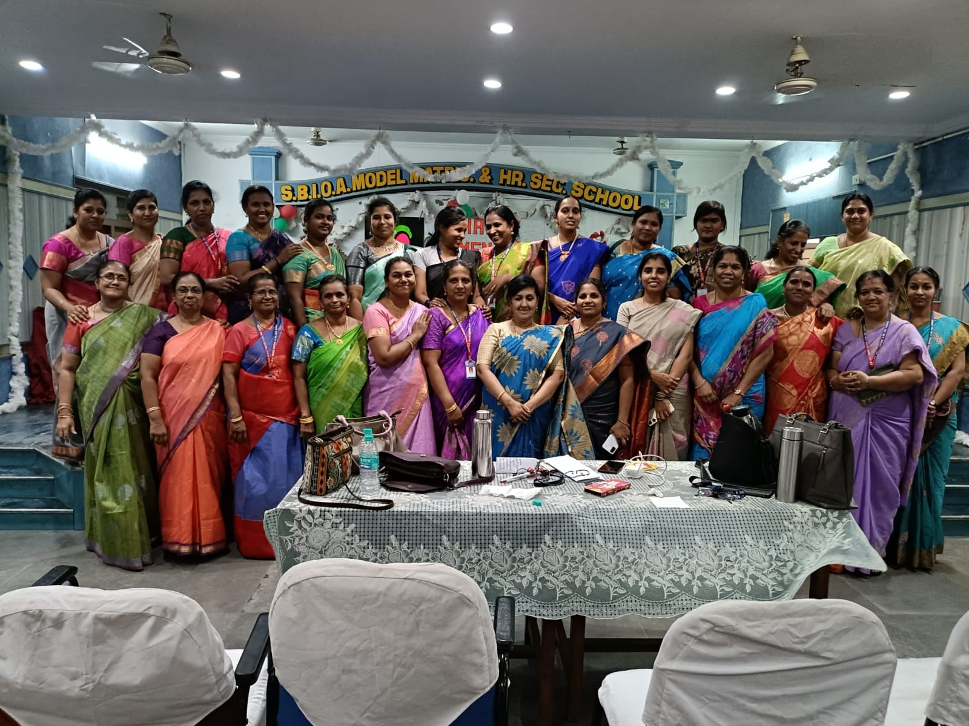
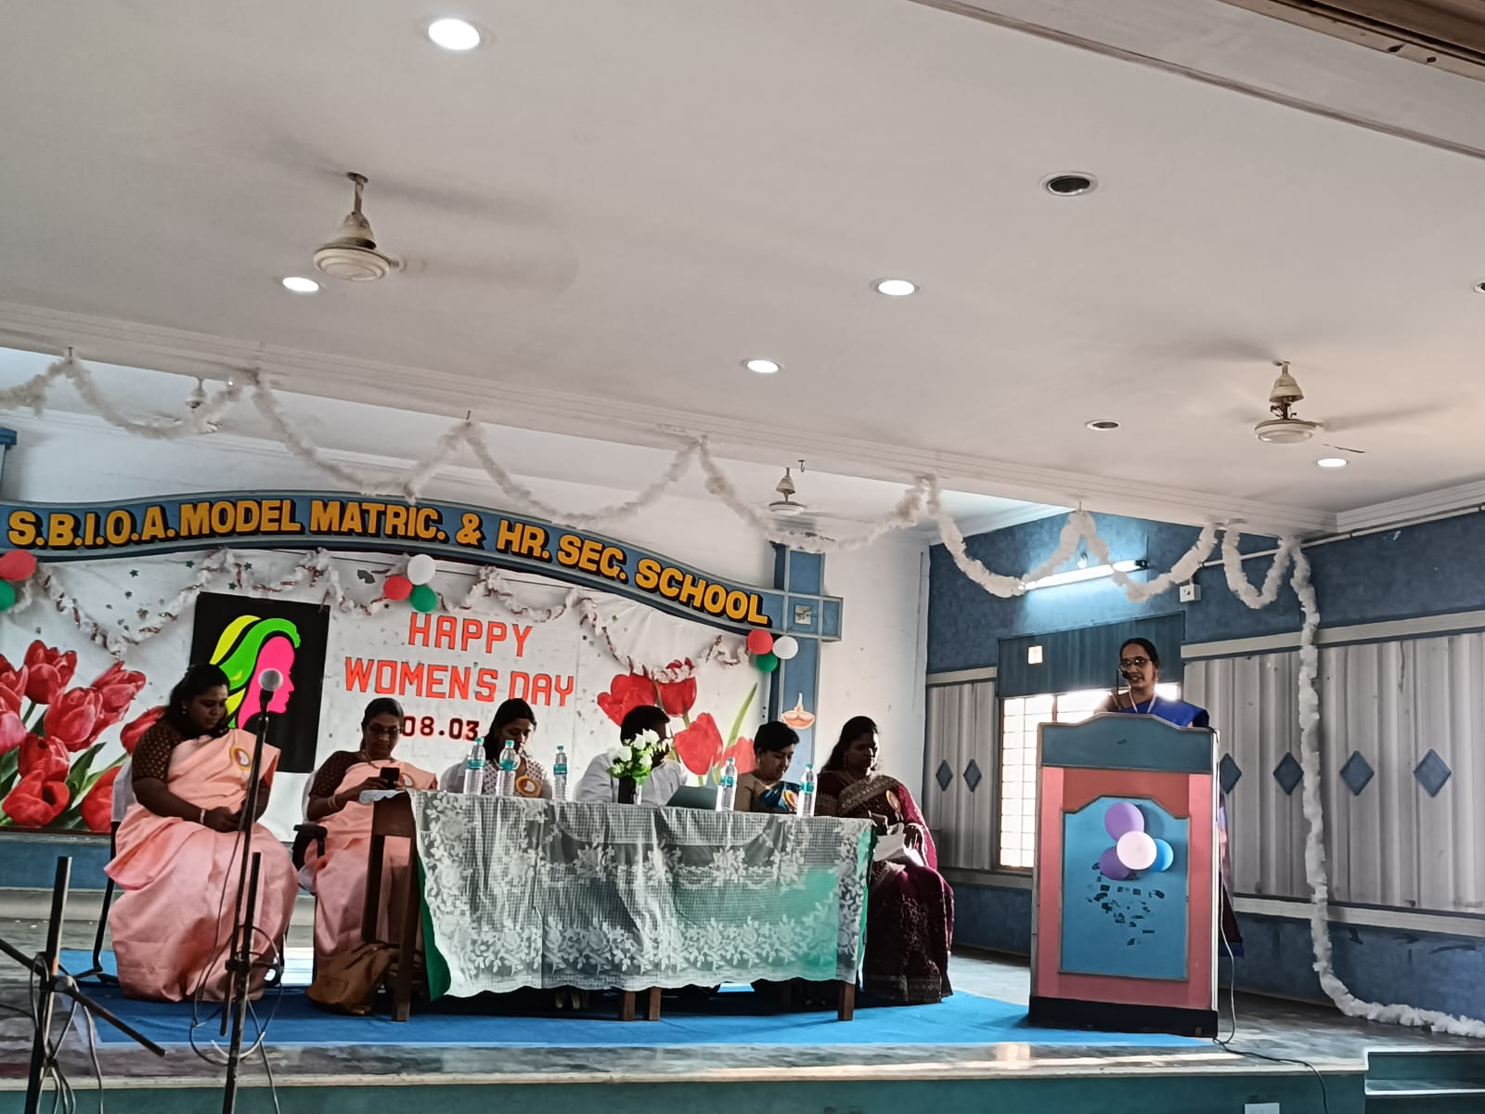
13.03.2024
ADITHYA BIRLA EDUCATION TRUST had organised a POWER MIND MATTERS under the topic – ‘GENERAL MENTAL HEALTH AWARENESS'. This session is conducted by Miss. Harini K. Our students from Std 7, 8 & 9 attended the session. They had the opportunity to know the ways to maintain a good mental health as well as how to overcome the negative thoughts.
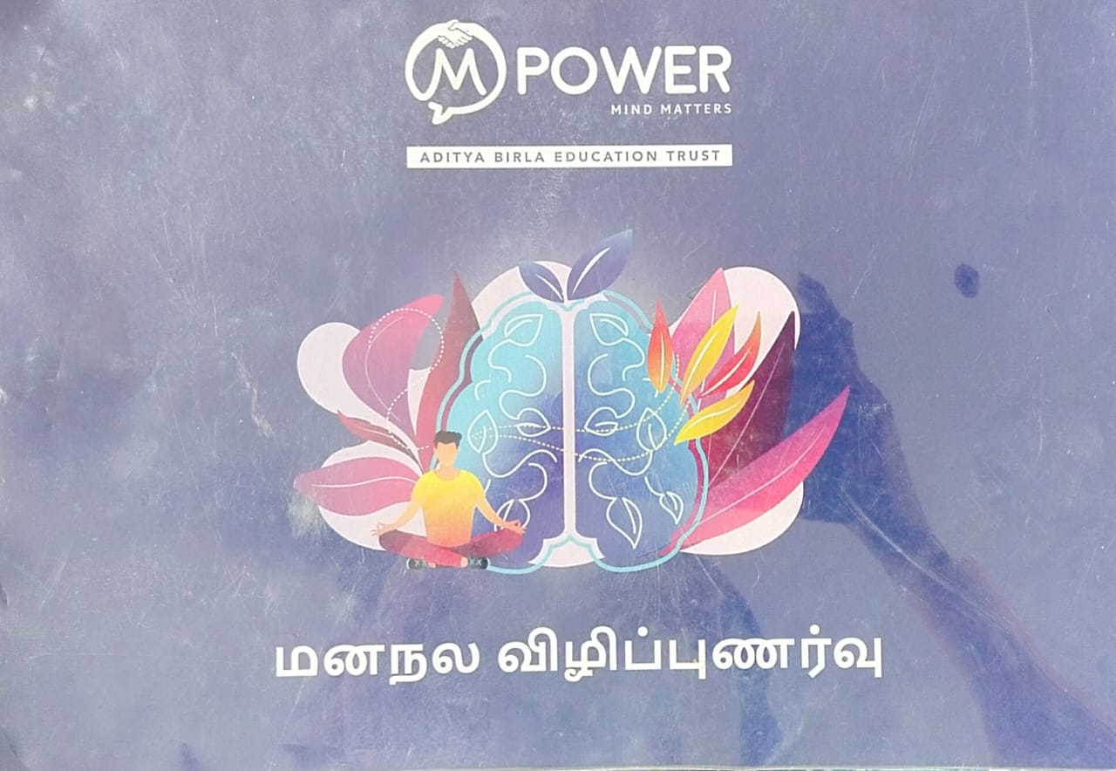
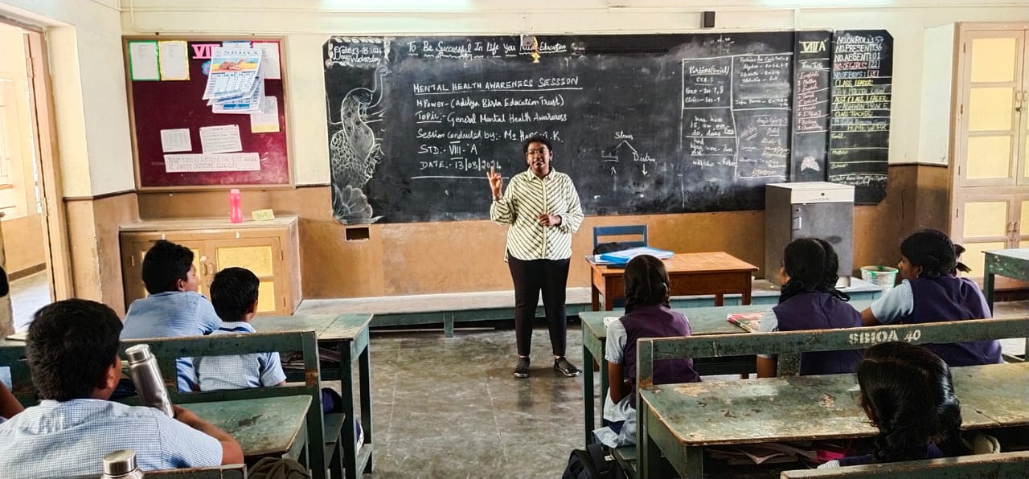
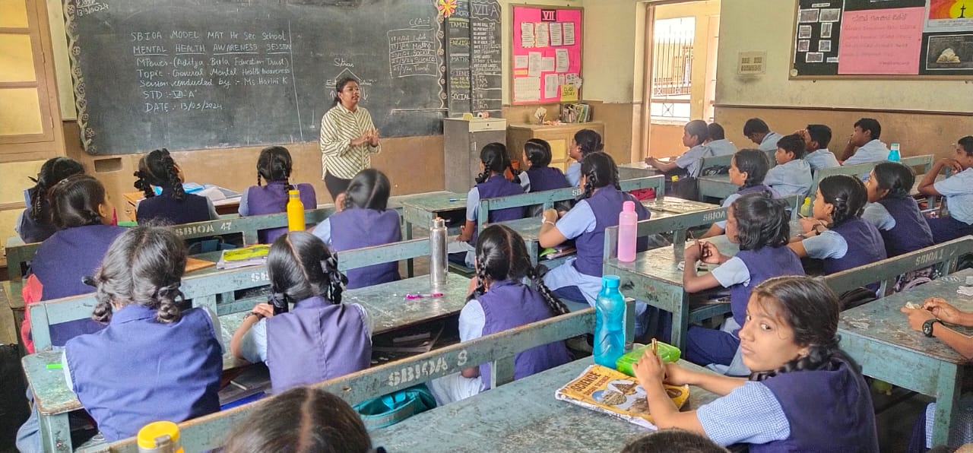
15.03.2024
On 15.03.24 'TAMIL ELAKIYA MANDRAM FINALE’ was conducted in a grand manner. Students of class 1 to 5 actively participated in the Recitation competition. The students stunned the audience with various entertainment programs like special song and dance to know the importance of Tamil Literature.
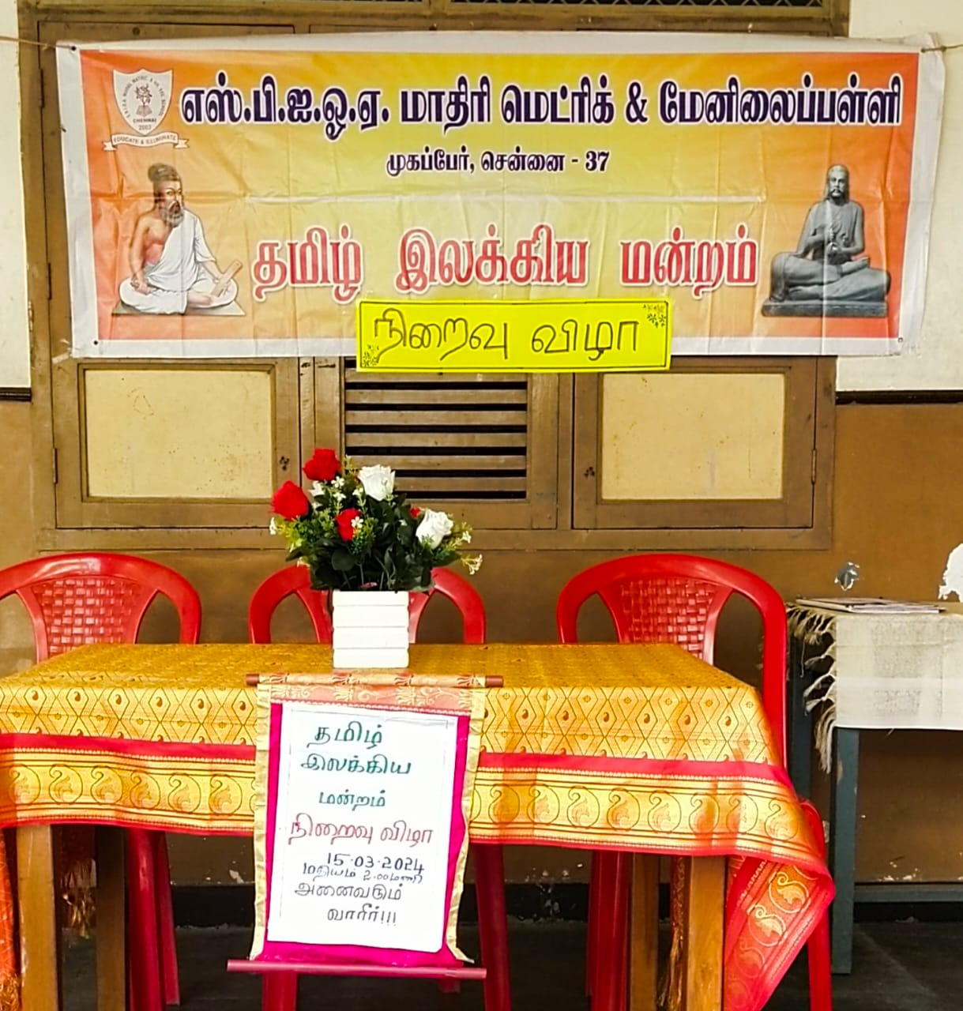
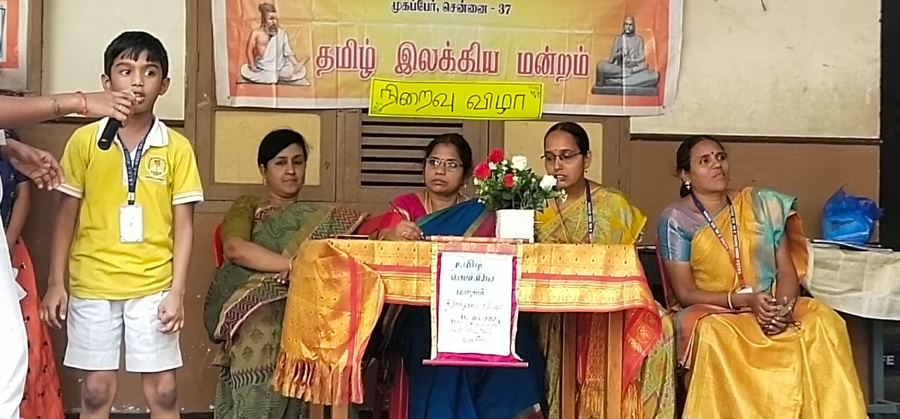
21.03.2024
On 21.03.24, Maharishi Vidya Mandir, Mangadu organised the National Cadet Corps Administrative Inspection 2024 and The Deputy Director General Cdr. Atul Kumar Rastogi interacted with our NCC Cadets.
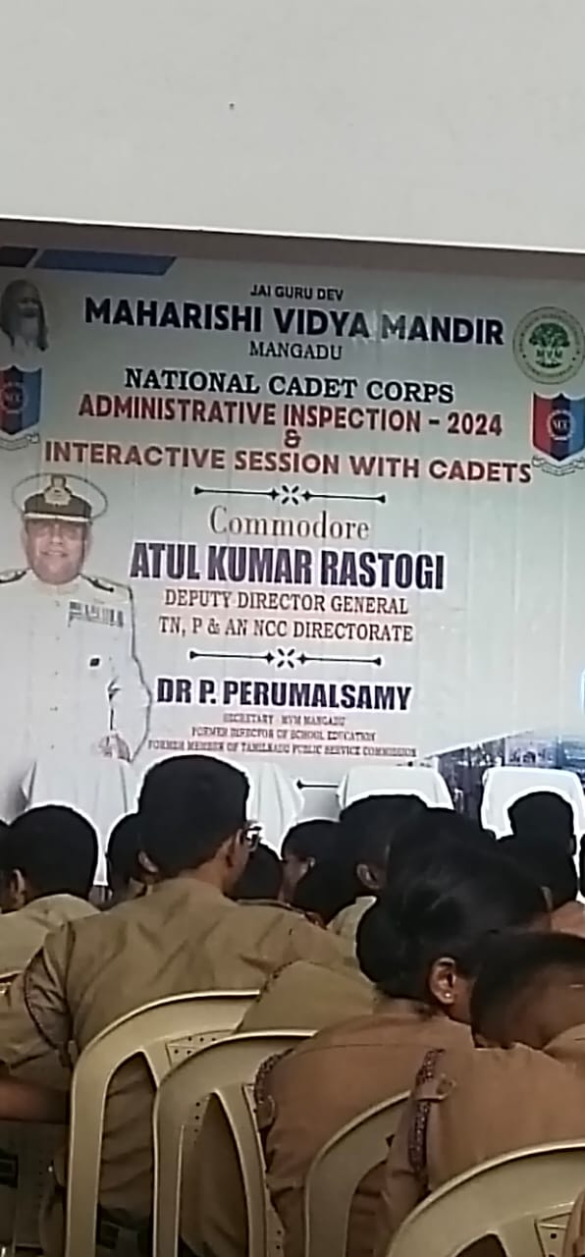
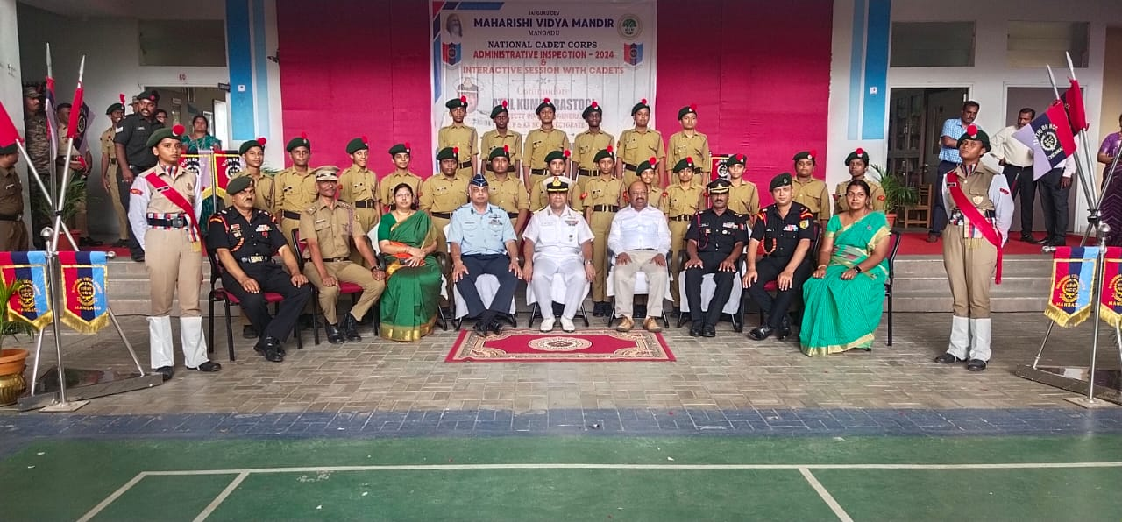

21.03.2024

KG Graduation Ceremony was held in our school campus on 21.03.24 with the blessings and in the presence of Mrs.S.Santhi, Associate Secretary, SBIOA Educational Trust, Correspondent of SBIOA Model Matric. & Hr. Sec. School Mr.P.Mohan. The esteemed Chief Guest for the occasion was Mrs. Shakira Unissa, Founder of Sun Shine Academy. The young graduates received their diplomas with blessings from the guests, marking a significant milestone in their educational journey. This was likely a heartwarming moment for the students, their families, and the teachers. The graduation ceremony was concluded with a variety of entertaining programs presented by the students of the Kindergarten and the Primary School. These performances have provided a delightful and celebratory ending to the event.
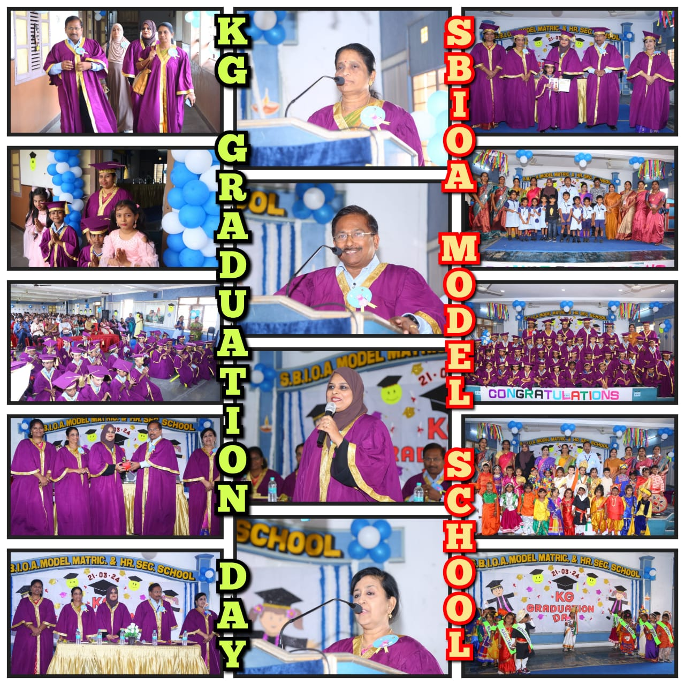
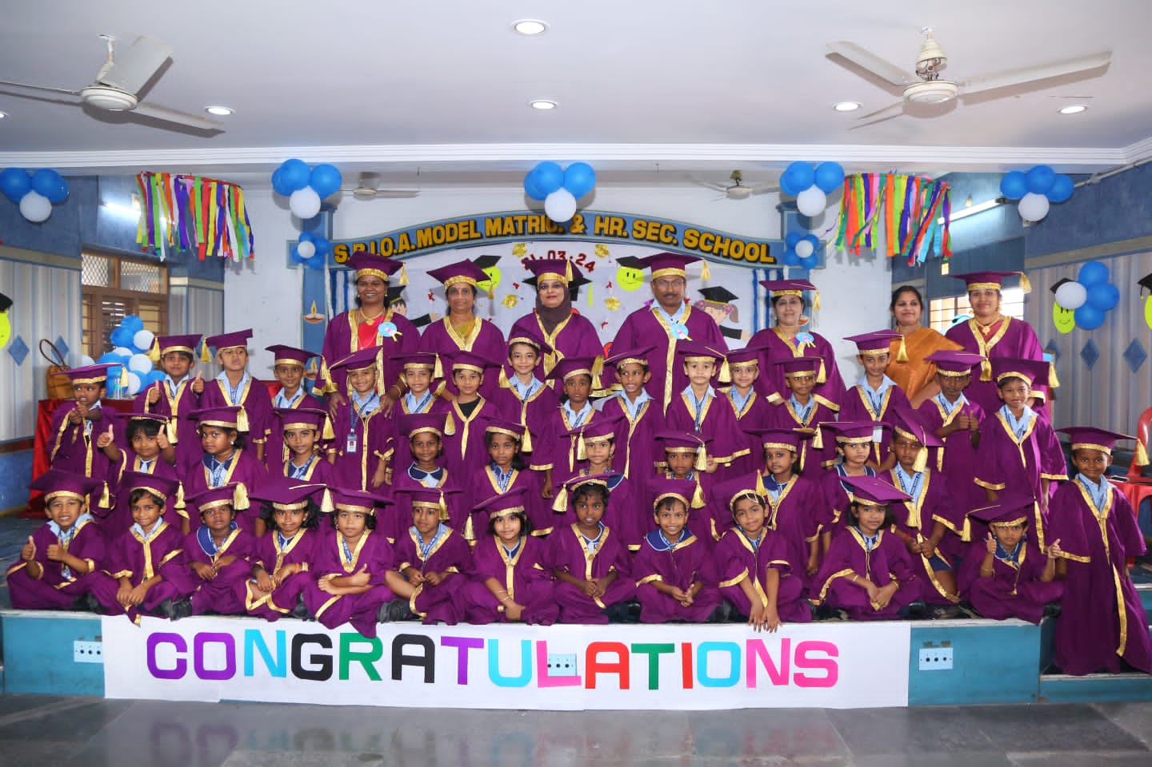

23.03.2024

A workshop was organized for the teachers handling KG, Std 1 & 2 at SBOA School and Junior college, Anna Nagar on 23rd March 2024. Mrs. Subhashree Suresh, Mrs. Savitha V K, Mrs. Shanthi Bala, Mrs. Malli Magesh and Ms. Sharal Jeba Malar along with other teachers from our sister concern schools of our esteemed institution attended the workshop. The resource person for the first session was Ms. Aparnasree, Jolly Phonics Trainer. She highlighted the significance of phonics in reading comprehension, fostering the same from an early age. Interactive activities were given to actively engage participants in practising the pronunciation of each letter. The second session was taken by Mrs. Anjana Pushparaj, Counselling Psychologist. She provided the teachers with a comprehensive exploration addressing the mental health needs of children. The speaker discussed on the challenging behaviours exhibited by children. She also introduced the principles of Cognitive Behaviour Therapy (CBT) and its relevance to addressing emotional and behavioural challenges in children. In conclusion, the seminar on Clinical Child Psychology provided us with valuable insights and practical strategies for providing the mental health and wellbeing of our students.
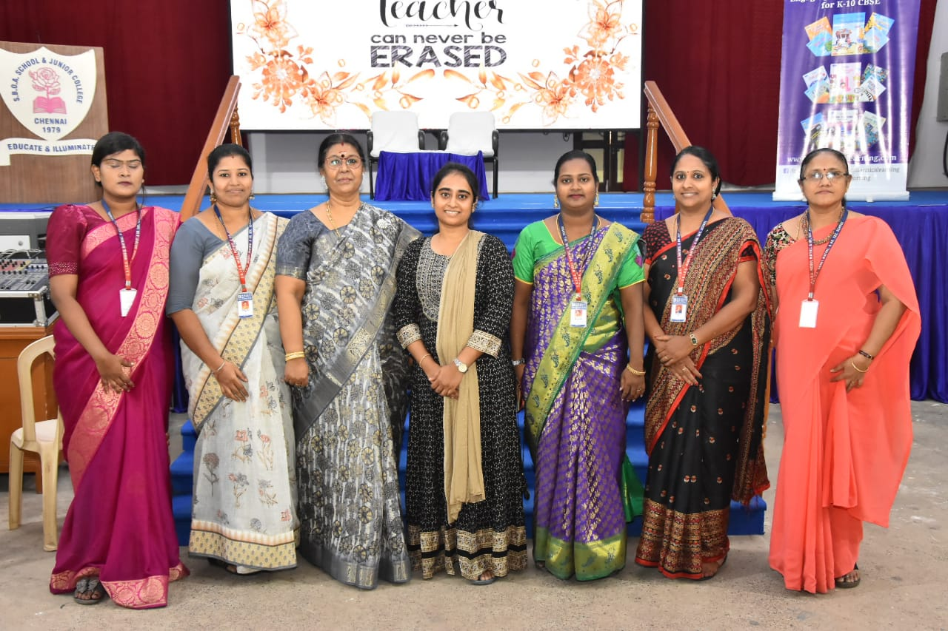

26.03.2024

On 26.03.24 ECA VALEDICTORY FUNCTION was held in our school. Shri. P. Mohan, Correspondent, SBIOA Model Matric & Hr. Sec. School delivered the special address. Mrs. Asha Robinson, Headmistress welcomed the gathering. Our alumni, Dr. Mrinalini Devi, Dept. Pediatrics, SRM Institute of Medical Science, Miss. Avanthika Kanagaraj, Talent Manager & Creative Producer, “The Route” & Mr. Adithya Charan, National Roller Skater/Athlete, HR Executive CCV Technologies were the Chief Guests. The prize winners of various competitions were rewarded with certificates and shield. The students electrified the audience with their variety entertainment.

